Computer Science NEA
Network simulator
Lucas Voller (2354)
UTC Portsmouth(58545)

Table of Contents
Computer Science NEA 1
Table of Contents 2
Analysis: 3
Description of the problem 3
Research: 4
Difference between emulators and simulators 4
Pre-existing software and its functions: 4
Network Topologies 7
Network Connection Limit 7
Network parts and systems 9
Graphical User Interfaces 13
Python Libraries 13
Topology storage 17
File Handling 18
End User Feedback 19
Objectives 20
Modelling 24
Design: 25
Hierarchy Chart 25
New Topology Section 26
Load Topology Section 31
Tutorial Section 32
Settings Section 32
Whole Chart 33
IPSO Chart 34
Data Dictionary 36
Interface Design 36
UML Diagram 38
Flowchart 40
Development: 41
Main 41
Main_Menu 41
Tutorial 41
File_Handling 42
Topology_Creator 43
Nodes 45
Adjacency_Storage 45
Hardware_Objects 46
Testing: 47
Evaluation: 54
Appendix: 56
End User Feedback Transcript 56
Code 58
Main.py 58
Main_Menu.py 58
Tutorial.py 60
File_Handling.py 67
Topology_Creator.py 74
Nodes.py 90
Adjacency_Storage.py 92
Hardware_Objects.py 96

Analysis:

Description of the problem
Many students studying computer science struggle to visualise how network topologies operate and how hardware components interact within a system. Traditional teaching and learning of networks involves diagrams and theoretical explanations, which can make it difficult for students to fully understand how and why networks are structured in certain ways.

Although hands-on experience could be a solution for this, it's incredibly impractical due to the cost and complexity it would take to bring these devices to students for learning and engaging with, making this solution infeasible for many classrooms.

As well as this, although the software available for network development/blueprinting is available, it's unfriendly to students, with it being designed for network professionals .Furthermore, the lack of guidance with these software may cause students not to engage with or not grasp how the network would connect in the real world.

To address this issue of a difficult learning experience for networks/topologies, I plan to develop a software that allows users to blueprint and visualise networks by assembling and connecting virtual components to develop their own networks. I see my program as a tool for teachers to guide the learning of networks with students as an engaging and interactive experience, which will make it more memorable to the students and intuitive once they get to exams.

Research:

Difference between emulators and simulators
Most software used for network visualisation currently available is either emulation or simulation software.

Simulators are helpful tools for network research that enable representation and visualisation. They predict the performance of a network design by modelling bandwidth and traffic flow needs. Although they do represent networks correctly, their main focus is not on educating others but on the professional calculation of the needs of large companies/corporations.

Network emulation is widely used for rapid prototyping and testing applications' behaviour under various network conditions. It replicates both hardware and software in a virtual environment, as well as some connecting to real hardware in a network. Emulated environments are also not used for educational purposes; the purpose of an emulated network is to accurately represent a new system, and it does this by representing every interaction. In the program, we want to represent everything, such as connections and hardware, but we do not want to model the interactions that would be had, as this would be confusing to students or people learning about networks.

Simulators use simplified, abstract versions of network parts to show how things might behave by taking in parameters to generate generalised, more distant results. Emulators, on the other hand, act more like real networks by running actual software and settings. This makes them better for testing how real applications will perform; however, worse for developing a conceptual understanding for the user.

In my approach to modelling, I will integrate both strategies by providing users the opportunity to develop a network topology and represent many different types of hardware and connections; however, I will not go into the depth of analysing and calculating the performance of a topology, as I believe this would be too complex for teaching how a network works.

Pre-existing software and its functions:
Cisco Packet Tracer
- The Cisco Packet Tracer is a network simulation tool developed by Cisco Systems in 2019. A combination of realistic simulation and visualisation experiences, assessment and activity authoring capabilities, and multi-user collaboration.

Whilst this software is good for more developed network engineers, I think it goes too in-depth for new students starting. An example of this is the fact that when you create a connection between 2 devices, the exact port you wish to use is selected by the user. However, the best thing about this software is the ability to create blueprints of networks on maps and drag and drop the hardware you want to use onto your workspace. Another positive is the clear distinction between different connections on the graph, with the option between colours, dotted and dashed lines.

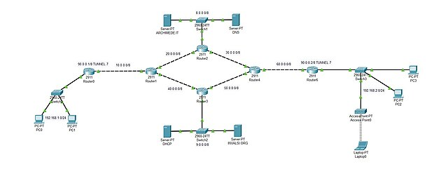

Cisco Packet Tracer. Available at: netcad.com/cisco-packet-tracer (Accessed 25/10/2025)

GNS3
- (Graphical Network Simulator 3)open-source computer network simulator that was first released in 2008. With the help of GNS3, one can create complex and realistic network topologies using real device images. A way to design and build networks of any size without the need for hardware.

One great aspect of this for students is the topology summary tab, where every device can be viewed and selected; however, GNS3 is used more for simulating/ testing the limits of real hardware interfacing simulated and real networks. This makes the actual topology builder harder as the focus is on testing software with simulated network loads.

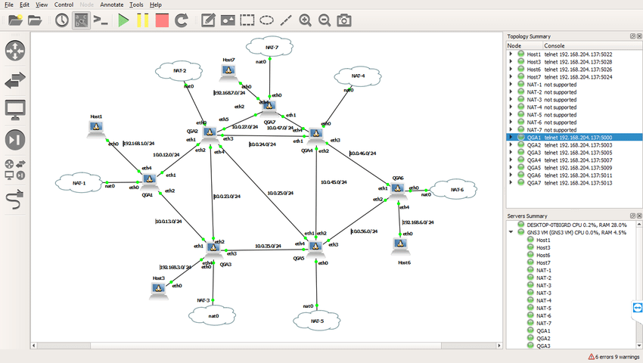

GNS3 Software. Available at: https://www.gns3.com/software (Accessed 25/10/25)

NS-3
- NS-3 is a discrete-event network simulator, targeted primarily for research and educational use. The goal of the ns-3 project is to develop a free and open source simulation environment suitable for networking research.

NS-3 requires a knowledge of coding to begin to use the software, as it's mainly a library in Python, which allows users to “animate” a network to show the movement of data between connections. Whilst this could be useful, I believe this is not what would be best to develop for educational software, as that requires the controls to operate the system to be easier to use, as the command style processes to reach the topology animations is hard to navigate.

.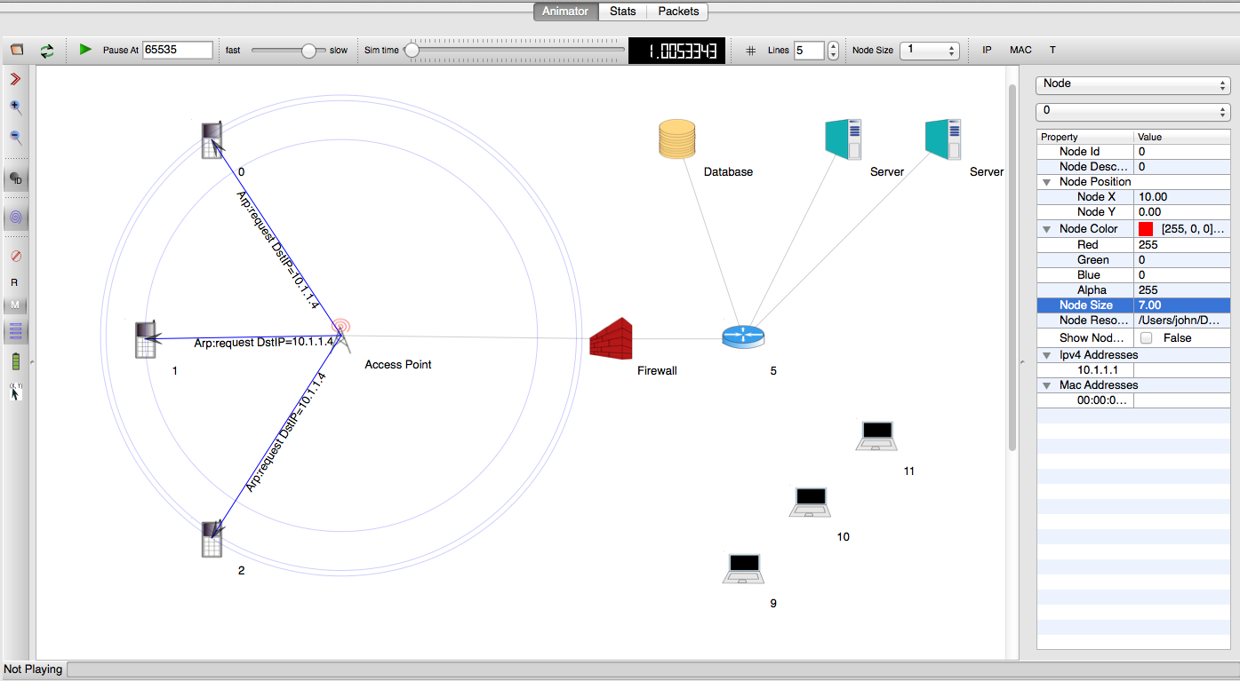

NS-3 . Available at: https://www.nsnam.org (Accessed 25/10/25)

EVE-NG
- a network automation tool that was first introduced in 2014. It can be used to create and run virtual networks using multiple hypervisors; it allows enterprises, e-learning providers/centres, individuals and group collaborators to create virtual proof of concepts, solutions and training environments.

EVE-N-G is an incredibly advanced up and up-and-coming software used by network developers to create topology blueprints.This includes an advanced section on server management with the ability to implement the software with others to begin developing rulesets on servers, etc. Not only does this software go in depth in all aspects it makes easily understandable graphs showing grouping and other features present in many instances of the software.

It is too advanced for students to use and learn from; however, there are many key parts, such as network grouping, which would be great to use in my project.

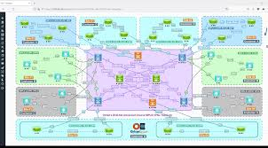

EVE-NG. Available at: https://www.eve-ng.net (Accessed 25/10/25)

Network Topologies
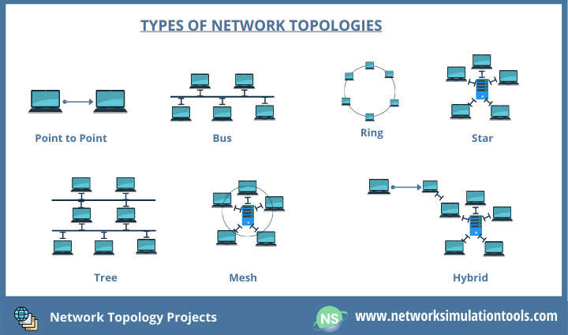

Networksimulationtools.Available:https://networksimulationtools.com/network-topology-projects/ (Accessed 28/10/25)

Through my application, I want students to be able to visualize topologies and network hardware better so that they can comprehend uses and better grasp the topic at school. or allow businesses to explain how their network would fit into a scenario.
I believe that by giving students prebuilt topologies that the teaching ability of my program will be reduced, as the interaction of creating it themselves under teacher instruction will have been taken away. This would only lessen the effect of the program in the lesson; therefore, I don't believe that I should include it.

Network Connection Limit
Network classes
Class A - everything before the first period in the IP address indicates the network, and everything after the device.

Class B - everything before the second period in the IP address indicates the network, and everything after indicates the service

Class C - everything before the third period in the IP address indicates the network, and everything before the device

Class D and E are not commonly used as its used on IPv6, which is not in as common use yet.

IP address parts
Every IP address has two parts. The first part indicates which network the address belongs to, and the second part specifies the device in that network. The length of which network depends on the network class.
In the class system, the 0 and 255 addresses are used for specific purposes. The 255th address broadcasts the packet to every host on the network, and the 0th address, as it only specifies the network and not the device on it.

Microsoft learn.Available at:https://learn.microsoft.com/en-us/troubleshoot/windows-client/networking/tcpip-addressing-and-subnetting (Accessed 28/10/2025)

Subnetting
A Subnet is a network inside a network. They make networks more efficient.
Because an IP address is limited to indicating a network and device address, it cannot indicate which subnet an IP packet should go to. Routers use a subnet mask to sort data into the subnetworks.
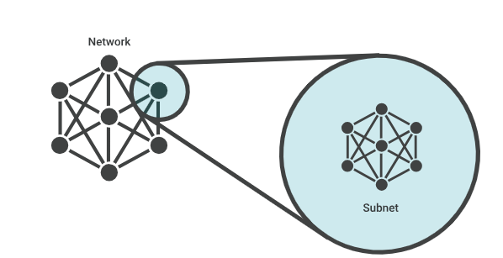

Cloudflare.Available at: https://www.cloudflare.com/en-gb/learning/network-layer/what-is-a-subnet/ (Accessed 28/10/2025)

The Type of networks I believe will most likely be used in my design will be class C, with the largest networks being in the hundreds of hosts, as well as being the most common type used for small networks..With this in mind, that limits the number of connections per router to 253 different connections, as the router will have to have its own address and the 2 special cases for 0 and 255.

Network parts and systems

Routers
A router is a networking device that forwards data packets between computer networks/It directs the traffic and takes information from 2 or more connections(data lines), determines the ultimate destination then directs the packet towards its destination.

Wikipedia.Available at : https://en.wikipedia.org/wiki/Router_(computing) (Accessed 28/10/2025)

Just as a switch connects multiple devices to create a network, a router connects multiple switches and their respective networks to form an even larger network. These networks may be in a single location or across multiple locations. When building a small business network, you will need one or more routers. In addition to connecting multiple networks, the router also allows networked devices and multiple users to access the Internet.

Cisco.Available at:https://www.cisco.com/c/en/us/solutions/small-business/resource-center/networking/network-switch-vs-router.html#~introduction Accessed(28/10/2025)

With both of these understandings, I will allow routers to connect to switches, unspecified devices and other routers only.

Network Switch
A Network switch forwards data packets between devices on the network. Switches send directly to the devices whereas Routers send to the network.
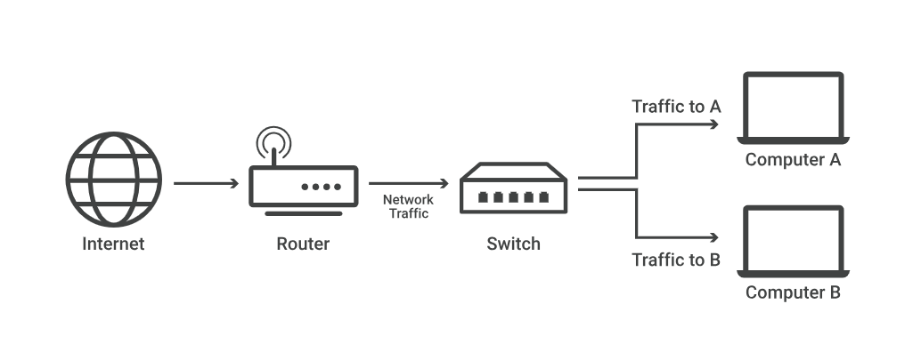
The difference between a router and a switch lies in the layers they operate on. Switches direct data to individual devices on a network, while routers communicate with switches and other routers.

Cloudflare.Available:https://www.cloudflare.com/learning/network-layer/what-is-a-network-switch/ (Accessed 28/10/25)

Switches can connect to other switches through stacking or daisy chaining to allow for more devices to connect to the network

Cisco-community.Available:https://community.cisco.com/t5/switching/is-it-ever-okay-to-daisy-chain-switches-no/td-p/3202085 (Accessed 28/10/25)

With this information, I will allow switches to connect to routers, unspecified devices and other switches

Modems
A modem (short for "modulator-demodulator") is a device that connects a network to the ISP (Internet Service Provider) through a physical connection.
There are three different Modems:
Dial uses a phone line to connect, The oldest type of connection,DSL uses a phone line with priorities, leading to higher speeds,Cable uses a cable TV line
Modems and routers are both essential components of a network. The modem provides access for the router to connect to other networks or Wide Area Networks (WANs). Most new routers combine the functionality of a modem, offering multi-role usage at a lower cost while maintaining the same level of usability.

Verizon.Available:https://www.verizon.com/home/internet/guides/modem-vs-router#:~:text=and%20individual%20purposes.-,What%20is%20a%20modem%3F,home%20network%20devices%20can%20use. (Accessed 28/10/2025)

With this information. I would allow modems to connect to the router or other device. .it would only have one connection; however, modems are outdated and no longer commonly used, therefore, I don't believe it should be included.

Firewall
A firewall is a network security device that acts as a barrier between a trusted network and an untrusted external network, such as the Internet. It manages the flow of incoming and outgoing network traffic according to predefined security rules. Firewalls are essential for protecting a network from malicious intrusions. There are several different types of firewalls available:

- Proxy- prevents a direct connection between the known and unknown networks by flooding data through proxy servers. May impact capabilities and applications supported
- Packet filtering- scrutinises each packet passing through and filters based on source and other parameters. These are simple and cost-effective. They cannot examine the contents of packets.
- Stateful- allows or blocks traffic based on state, port and protocol. Monitors all activity of a connection until it is closed. Filtering is made based on admin-defined rules.
- Web application(WAF)- acts as intermediary between internal and external networks, handling requests on behalf of the network. High security can inspect packets and filter out unauthorised data.
- Unified threat Management(UTM)- in a loosely coupled way, combines the functions of a stateful firewall with intrusion prevention and antivirus. This may include cloud management.
- Next-generation firewalls (NGFWs) provide capabilities beyond a traditional stateful firewall. They include additional features like application awareness and control, intrusion prevention, URL filtering, geolocation and reputation, and threat intelligence.
- AI-powered- use of AI and machine learning to enhance threat protection and security. Work in real-time to analyse network traffic, identify patterns and help organisations automate lifecycle management.
- Virtual- deployed on cloud environments to secure applications and websites
- Cloud-native- secure applications and workload infrastructure at scale.

Implementing a firewall can greatly improve the security of your network and protect sensitive data. Firewalls safeguard against common network threats and attacks, making them essential in the face of increasingly sophisticated cyber threats. Additionally, they help organizations meet compliance requirements and adhere to industry best practices.

Cisco.Available:https://www.cisco.com/site/us/en/learn/topics/security/what-is-a-firewall.html#jump-anchor-1 (Accessed 28/10/25)

While there are various types of firewalls available, I have chosen to represent all of them with a single icon that functions as a packet-filtering firewall. This streamlined representation will simplify the overall network topology, making it easier to understand the concept and the role of firewalls within the system. By focusing on one icon, I aim to enhance clarity and facilitate a better grasp of how firewalls manage and filter network traffic.

Hub
A hub is a networking device that serves as a central connection point within a LAN. It is used to receive data signals from connected devices and broadcast them to all other connected devices, regardless of the intended recipient.

Anker. Available:
https://www.anker.com/blogs/hubs-and-docks/what-is-a-hub-understanding-the-basics-of-networking-devices (Accessed 28/10/25)

Repeater
Repeaters are a type of network device that amplifies incoming signals and rebroadcasts them over a wider area or a higher network layer than the original signal. In networks, a repeater is used to increase its reach, restore a damaged or weak signal or provide access to inaccessible nodes. They accept signals from one LAN terminal cable and retransmit them over other cable segments in their original forms, preventing signal weakening and regenerating signal strength.

Nordvpn cyber-security glossary.Available: https://nordvpn.com/cybersecurity/glossary/repeater/#:~:text=Repeater%20is%20a%20type%20of,provide%20access%20to%20inaccessible%20nodes. (Accessed 28/10/25)

I will not implement this into my program because the use of repeaters is quite limited and depends on the length of the wire, which can be very long yet serve the same purpose. Moreover, repeaters are primarily used in very large networks or with short-range wires. Instead, I will simply use a wire to demonstrate the connection without detailing each connection's specific lengths etc; I will only indicate the type of wire being used.

Access Point
An access point is a wireless network device that acts as a portal for devices to connect to a local area network. Access points are used for extending the wireless coverage of an existing network and for increasing the number of users that can connect to it.
Access points will only connect to unspecified devices, routers and switches.

Ligowave.Available:https://www.ligowave.com/difference-between-access-point-and-router#:~:text=An%20access%20point%20is%20a,that%20can%20connect%20to%20it. (Accessed 28/10/25)

Ethernet cables
Ethernet is a method for connecting computers and other network devices within a physical area, commonly known as a local area network (LAN). An Ethernet network enables computers and devices to share files, information, and data efficiently.

Bridges
Bridges separate a network into segments of smaller LANS which connect to create a Larger LAN. Routers connect two separate networks whereas a bridge connects the networks into one larger network. If one or more segments are wireless the device is a wireless bridge. Can be hardware or software.

Wikipedia.Available:https://en.wikipedia.org/wiki/Network_bridge (Accessed 28/10/25)

For my application, I will use a bridge to connect topologies created by the user to show the links how different networks are connected.A good feature would be the inclusion of different topologies on different windows connected using a bridge to show the transfer of data across multiple networks.

Graphical User Interfaces
GUI:A form of user interface that allows users to interact with electronic devices through graphical icons and visual indicators such as secondary notation. This makes it easier for beginners to pick up the processes.
A good GUI should:
- Be attractive and pleasing to the eye
- Allow the user to try out different options easily
- Be easy to use
- Use suitable colours for key areas
- Use words that are easy to understand and aimed at the type of user
- Have help documentation

BBC-Bitesize.Available:https://www.bbc.co.uk/bitesize/guides/zts8v9q/revision/8 (Accessed 28/10/25)

Wikipedia.Available:https://en.wikipedia.org/wiki/Graphical_user_interface (Accessed 28/10/25)

Python Libraries
Tkinter
Tkinter is Python’s built-in library for creating graphical user interfaces, making it a convenient and accessible choice for GUI development.Tkinter provides a range of basic widgets like buttons, labels, and entry fields, and supports layout management through geometry managers.it may lack the modern look and advanced features of other frameworks, its simplicity and integration with Python make it a solid option for educational tools.

Tkinter.Available:https://realpython.com/python-gui-tkinter/ ( Accessed 28/10/25)

PysimpleGUI
PySimpleGUI is a high-level Python GUI framework designed to simplify interface development. It wraps around lower-level libraries like Tkinter.While it may not offer the advanced styling or flexibility of more complex frameworks, it excels in rapid prototyping and educational tools.

PysimpleGUI.Available:https://docs.pysimplegui.com/en/latest/ (Accessed 28/10/25)

wxPython
wxPython is a GUI toolkit that lets you build apps with a native look on Windows, macOS, and Linux. It uses real system widgets, so your app feels like it belongs on the user’s computer. It gives you lots of control over layout and design, which is great for detailed interfaces.wxPython is a powerful, cross-platform GUI toolkit that wraps the native C++ .

Wxpython.Available:https://docs.wxpython.org/ (Accessed 28/10/25)

PyQT
PyQt is a Python library for building modern, cross-platform desktop apps. It offers lots of tools and a visual designer for creating detailed interfaces. While it gives a polished result, it’s more complex than simpler options like Tkinter or PySimpleGUI.

PyQT.Available:https://realpython.com/python-pyqt-gui-calculator/#:~:text=PyQt%20is%20a%20Python%20binding,graphical%20user%20interfaces%20(GUIs). (Accessed 28/10/25)

NetworkX
NetworkX is a Python library for creating and analyzing network graphs. It lets you build structures like nodes and edges to represent networks, then explore how they behave using built-in algorithms

NetworkX.Available:https://networkx.org/ (Accessed 28/10/25)

DearPyGUI Research

DearPyGUI is a fast, cross-platform GUI toolkit for Python, using GPU-based rendering for high performance. It offers various interactive elements like buttons, plots, and tables. It supports asynchronous functions and comes with a built-in demo and developer tools.DearPyGUI supports integration with various Python modules, allowing you to enhance your applications with additional functionalities from other libraries. This flexibility makes it a versatile choice for complex projects.DearPyGUI Functions Include:

Buttons: Functions for creating and managing buttons in the GUI.
Windows: Functions for creating and managing windows, including visibility, titles, and dimensions.
Text: Functions for adding and managing text elements.
Input Fields: Functions for creating and managing text input fields.
Sliders: Functions for creating and managing sliders for numerical input.
Checkboxes: Functions for creating and managing checkboxes.
Combo Boxes: Functions for creating and managing drop-down combo boxes.
Color Pickers: Functions for creating and managing color picker interfaces.
Tables: Functions for creating and managing tables for data display.
Plots: Functions for creating and managing graphical data plots.
Images: Functions for displaying and managing images.
Control Elements: General functions for managing visibility, enabling/disabling, deleting, and setting properties of GUI elements.
Modify Properties: Functions for changing values, colors, dimensions, and positions of GUI elements.
Layouts: Functions for structuring the layout of the GUI.
Utilities: General utility functions for managing the GUI and item interactions.
Drawing: Functions for custom drawing capabilities on a drawing layer.

DearPyGui.Available:https://dearpygui.readthedocs.io/en/latest/ (Accessed 28/10/25)

DearPyGUI contends with Tkinter due to its modern design and performance advantages, such as a wide range of interactive widgets and suitability for real-time applications. It offers extensive customization and flexibility. Tkinter, on the other hand, is simple, easy to use, part of the standard Python library, and broadly compatible.

DearPyGui.Available:https://dearpygui.readthedocs.io/en/latest/tutorials/first-steps.html (Accessed 28/10/25)

Further TKinter Research
Python Tkinter is a standard GUI (Graphical User Interface) library for Python which provides a fast and easy way to create desktop applications. Tkinter provides a variety of widgets like buttons, labels, text boxes, menus and more that can be used to create interactive user interfaces. Tkinter supports event-driven programming, like javascript, where actions are taken in response to user events like clicks or keypresses. This is a key feature of why I chose it as the event tracking built into Tkinter makes it easy to have multiple options presented to the user without checking every button all the time.

Geeks for geeks.Availability:https://www.geeksforgeeks.org/python-gui-tkinter/ (Accessed 28/10/25)

There are many different “widgets” in Tkinter. A widget is a graphical component that a user can interact with.Each widget is an instance of a class in the module, having methods and attributes allowing you to configure the widget appearance behaviour function added to windows or frames using layout managers like pack grid or place to determine position
Geeks for geeks.Available:https://www.geeksforgeeks.org/what-are-widgets-in-tkinter/ (Accessed 28/10/25)

I chose dearPyGUI over Tkinter for my NEA due to the wide range of customization and the engaging interfaces for the users.Aswell as this, I found that the DearPyGui library is easier to work with than tkinter when coding a gui.

Dear PyGui is a Python library that enables the creation of interactive GUIs . Coding with Dear PyGui involves a series of function calls that directly create and update GUI elements within a continuous execution cycle. The entire graphical interface is redrawn on each frame according to the present state of the code, rather than storing a constant representation of the interface. This simplifies the process of updating the interface compared to other libraries.

Within this framework, the viewport serves as the main application window – the area where all graphical components are displayed. After setting up the viewport, developers organise their elements using containers such as windows, groups, and child elements. These containers allow for a hierarchical layout.

Each function call not only specifies the visual component ,but also ties its behaviour to designated callbacks.

AST
During the Project i had to research and use AST to turn the stored text from the files and turn them into the lateral values they were required to be for the program to work.
For this transfer from text to variable i used the literal_eval function .

Ast documentation.Availablehttps://docs.python.org/3/library/ast.html (Accessed 28/10/25)

OS
During the project i also had to use the OS python library for File handling.the os library was only used for listingt the files in a specific directory and joining file paths together.

python(os).Available:https://docs.python.org/3/library/os.html (Accessed 28/10/25)

Topology storage
To store the topology, a graph will likely be used to represent the connections when storing and viewing the topology. To do this either an adjacency list or matrix will hate to be used to allow the file to be stored easily.

Adjacency Lists
An adjacency list stores the connections of nodes in a list of lists with each list representing the nodes and then the connections to that node. It only stores the connected nodes to a certain node and doesnt store the non connected nodes for that node. Its storage space is proportional to the edges and vertices .

Wikipedia.Available:https://en.wikipedia.org/wiki/Adjacency_list (Accessed 28/10/25)

Adjacency Matrices
Stores a graph in a matrix with every row connected to every column and an integer or boolean expression in the intersection of column and row to represent an edge on the graph.Less storage efficient than Adjacency lists but can be more space efficient.

Wikipedia.Available:https://en.wikipedia.org/wiki/Adjacency_matrix (Accessed 28/10/25)

Due to the faster adding and checking of neighbour nodes of adjacency lists i have decided to use them over adjacency matrices to store my graph as during my programs operation i believe the requirement to do operations to the graph should be more important than the storage of the graph

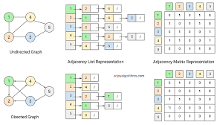

File Handling
During the project, i also had to Research more indepth file handling to better store my files during the project.This led to my use in os and ast.
There are two main modules in python that deal with file and directory paths. Pathlib and os.Whilst Pathlib offers more functionality for reading and writing files, i only had use for the features of getting filenames and creating filpaths therefore i used os to have a more basic module which would be easier to understand.

File directories and Paths
Most operating systems use different file path naming formats,i used windows as its the operating system on my device making it easier to understand.And for this i used the conventions dictated on the windows website for file path naming and rules such as the direction of the slash and path normalisation

“If a path isn't fully qualified, Windows applies the current directory to it. UNCs and device paths don't have the current directory applied. Neither does a full drive with separator C:\.
If the path starts with a single component separator, the drive from the current directory is applied. For example, if the file path is \utilities and the current directory is C:\temp\, normalization produces C:\utilities.”

Microsoft.Available:http://learn.microsoft.com/en-us/dotnet/standard/io/file-path-formats (Accessed 30/10/25)

- An absolute path, which always begins with the root folder
- A relative path, which is relative to the program’s current working directory
I used relative paths so that the file saving can work on other devices aswell because if i did an abzolute path,the user would have to store the program in the exact same directories with the exact same naming as me.

PythonCheetSheet.Available:https://www.pythoncheatsheet.org/cheatsheet/file-directory-path (Accessed 30/10/25)

End User Feedback
I created a questionnaire to collect data for my project, which I sent to 77 students and staff to understand the preferences of end users for similar programs.
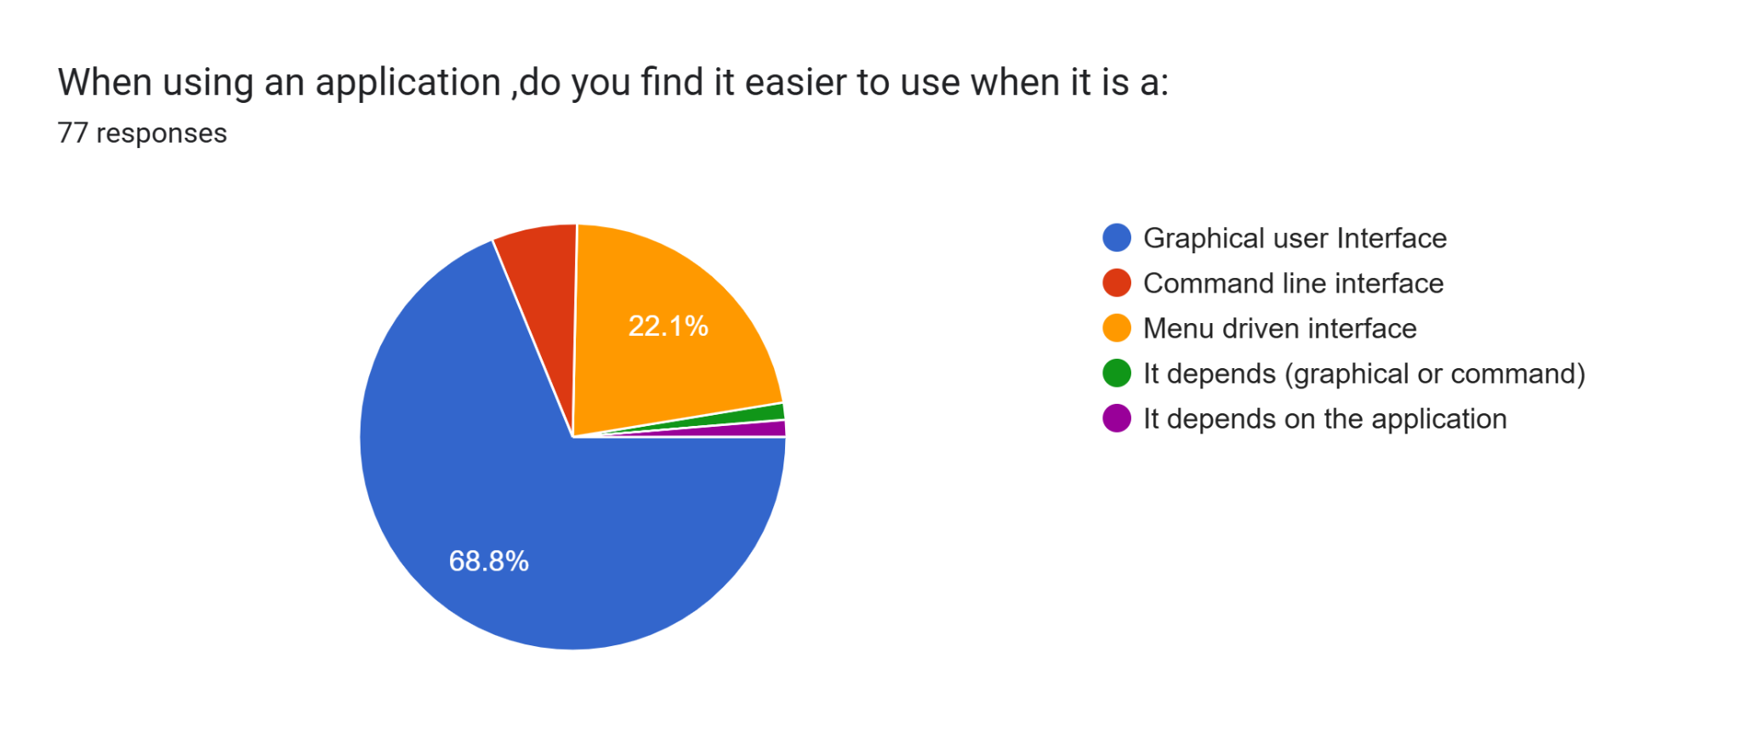
Given the prevalence of graphical and menu-driven interfaces, I chose to implement both types of processes for my program's user interface. I will do this by using graphical menus with buttons and icons so users can easily understand, be comfortable with using, and quickly grasp how the program works.
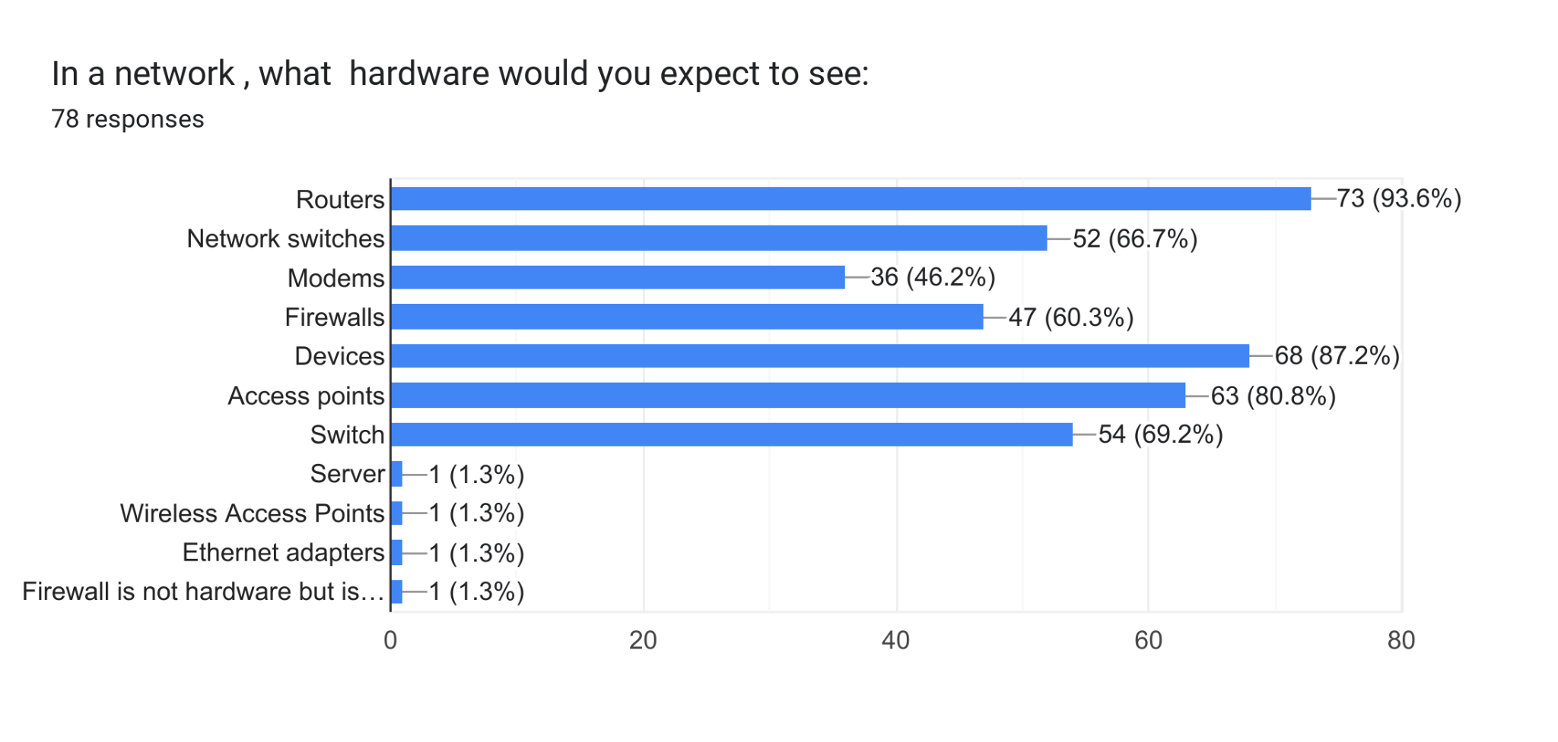
I will incorporate all the hardware that users typically expect to see based on the data I have collected. Although modems are not as commonly used today, I will include them for users who may want to understand how they fit into older networks. However, I will not include Ethernet adapters, as my research suggests that they are not a relevant component of the network but rather serve as adapters for devices that already have Ethernet connection capabilities.

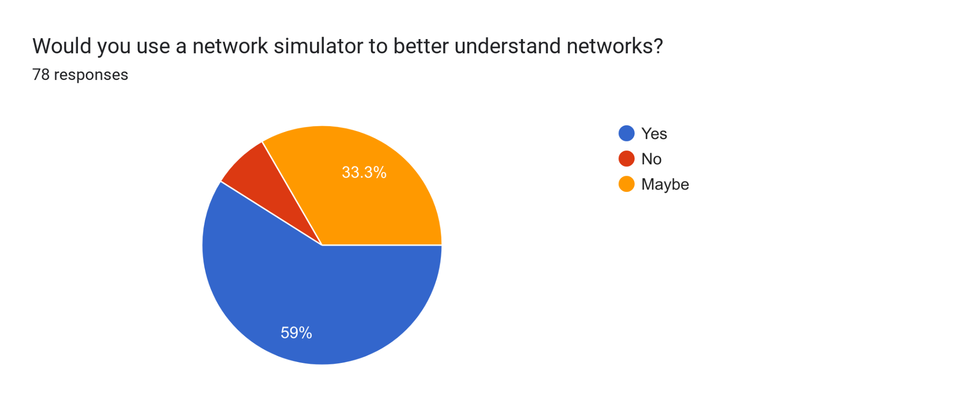
With this data, I believe my end users will use my program as the greater proportion of responses showed that a network simulator would help them understand networks before they make them or without making them.
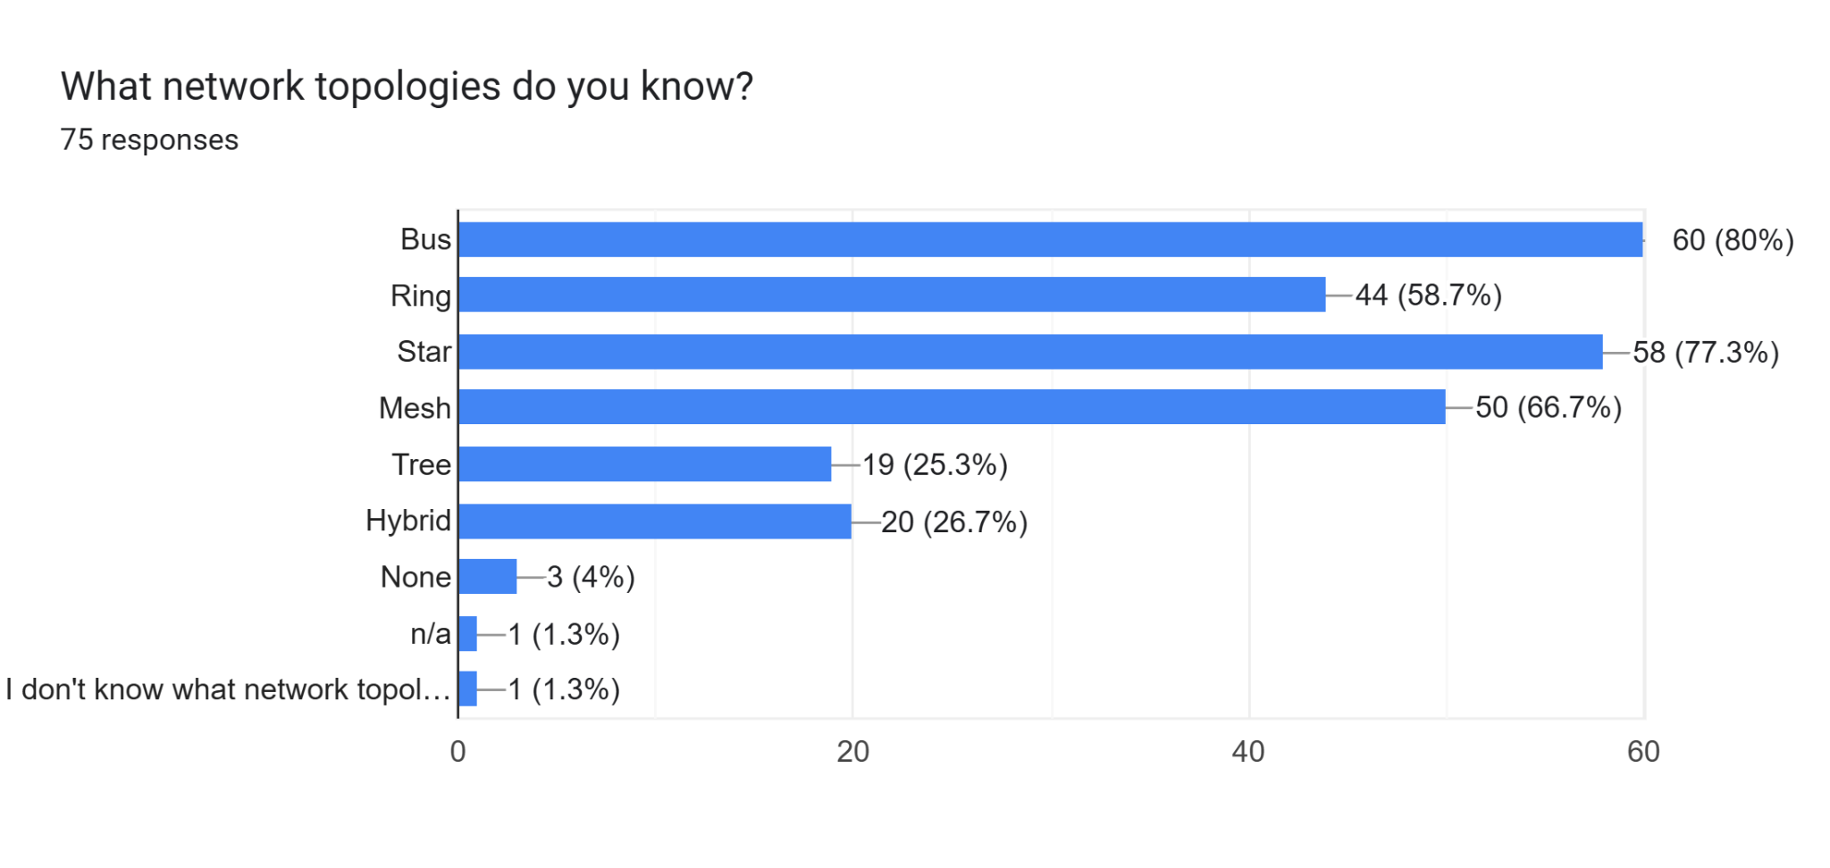
With this I believe as one of the menus in my interface the ability to load preset topologies would be useful to be able to view topologies students must learn for exams or to see frequently created topologies.
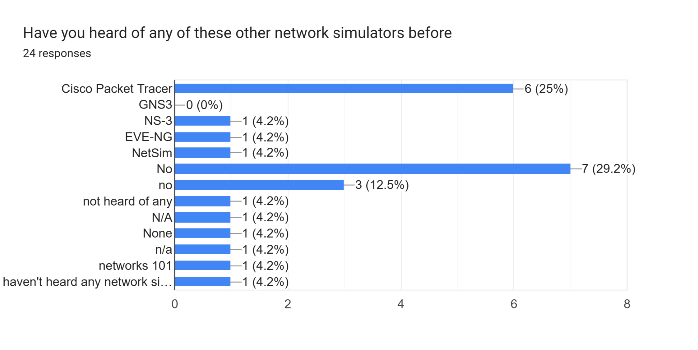
I would like to use the layout of the most commonly known network simulators to create inspiration for the UI layout in my modelling area and some of the useful features they include

Objectives
- Screens:
  - Have a Main Menu screen that opens when the program starts
  - Have a new topology screen
  - Have a tutorial screen
  - Have a settings screen
  - Have a Load File screen
- Main Menu screen
  - Have a button which takes you to:
    - New topology screen
    - Tutorial Screen
    - Settings screen
    - Load File Screen
- New Topology screen
  - Have a Menu which controls the main components needed by the user in this section:
    - Settings button which takes the user to the settings screen
    - Main Menu button which takes the user back to the main menu screen
    - Save button which begins save process
    - Hardware selection button that presents the hardware selection menu
    - Edit menu button that shows edit menu
  - Hardware selection Menu
    - Has a button for each type of hardware,which when selected provides the user with the option to add it to the topology and presents information about the hardware in the hardware information window:
      - Routers
        - Be able to add to the topology
        - Be able to cancel adding to the topology
      - Network Switch
        - Be able to add to the topology
        - Be able to cancel adding to the topology
      - Unspecified device
        - Must ask for the number of ports on the device to accommodate for it
          - User sets total ports at creation and is stored for each unspecified device
        - Be able to add to the topology
        - Be able to cancel adding to the topology
      - Access Point
        - Be able to add to the topology
        - Be able to cancel adding to the topology
      - Server
        - Be able to add to the topology
        - Be able to cancel adding to the topology
      - Firewall
        - Be able to add to the topology
        - Be able to cancel adding to the topology
  - Edit Menu
    - Allows the user to select hardware to edit the properties of:
      - Add a connection between 2 devices
        - Wireless connections
        - Wired connections
      - Remove a connection
      - Remove the selected hardware
    - Present the user with the properties of the hardware
      - Ports available
      - Total Ports
      - Hardware Name
      - Hardware ID
  - Sandbox
    - Appropriate icons for the different hardware types:
      - Routers
      - Network Switch
      - Unspecified device
      - Access Point
      - Server
      - Firewall
    - Allow the user to drag and drop the hardware icons on the topology to move them to wanted locations
    - Show appropriate types of connections between connected hardware:
      - Wireless
      - Wired
    - View
      - Zoom in
      - Zoom out
      - Move on topology to see different parts
    - Spread the hardware so that its easy for user to understand
  - Hardware information window
    - Presents appropriate information about the different hardware when the hardware is selected in the hardware selector:
      - Routers
      - Network Switch
      - Unspecified device
      - Access Point
      - Server
      - Firewall
  - Save process
    - Receives a user inputted filename
    - Receives user wanted file location
    - Saves under users filename in filelocation
- Tutorial screen
  - Steps
    - Allow for interaction to learn the different core actions needed for creating topologies(interaction being the process of doing the action to learn how it works)
      - Adding hardware to the topology
      - Saving a topology
      - Editing the topology
    - Provide necessary information on how to use the program
      - Information about the hardware selection and how to add it to the topology
      - How to save
      - How to edit the topology

    - Use images to better show the user how to use the program
  - Options
    - Option to return to the main menu on each step
    - Option to progress onto the next tutorial step for each step
- Settings screen
  - Options
    - Return to main menu
    - Change brightness
    - Change Theme
- Load File screen
  - Options
    - Cancel load and return to main menu
    - Select a file from the folder to open
  - Once a file is selected ,goes to the new topology screen but adds the loaded variables to the topology

Modelling
Inspired by the dark mode on apps like Seneca Learning I think the dark purple hues promote productivity and allow users to use the app at all times of the day without hurting their eyes during late-night revision sessions. This is similar also to how PowerPoint lays out menu selection.
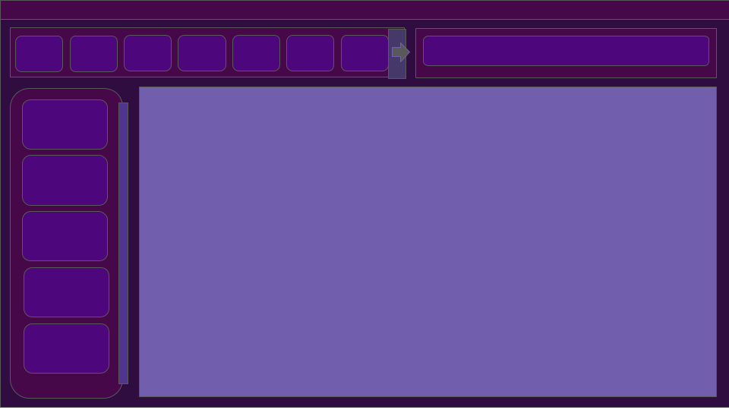

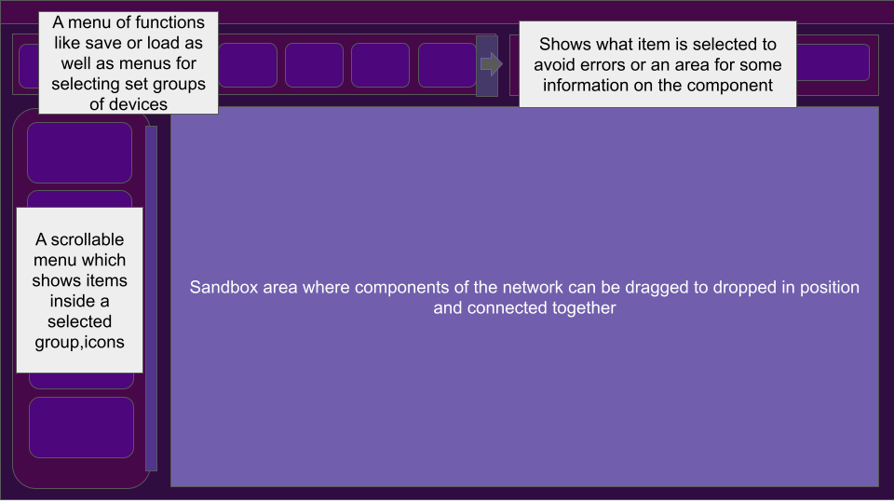

Design:

Hierarchy Chart
Online version available at:https://drive.google.com/drive/folders/1AF4h9GPF6kvm5AvMDVLzenjsukFjcKnh?usp=sharing
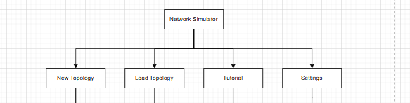

New Topology Section
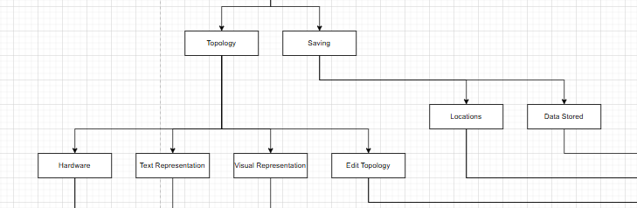
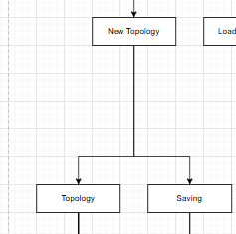
Hardware Section:
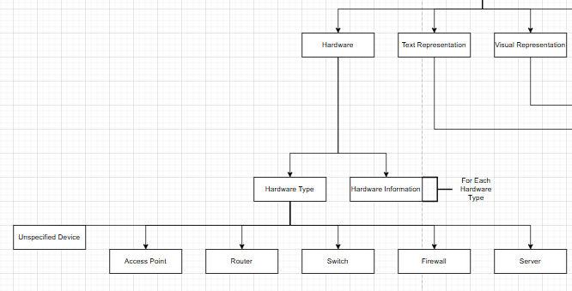
Text Representation Section:
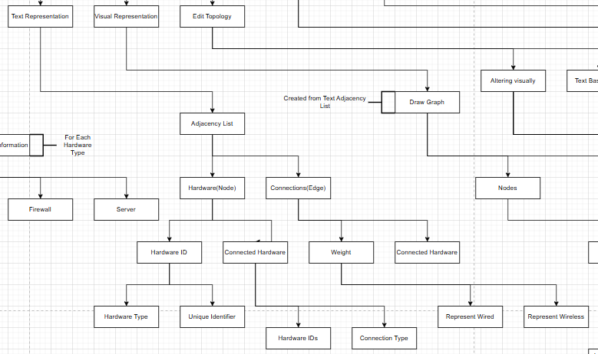
Visual representation Section:
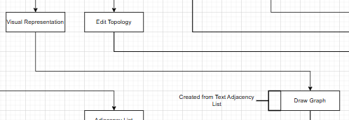
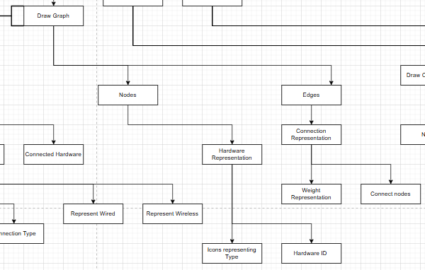
Edit Topology Section:

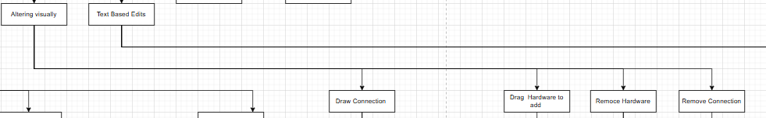
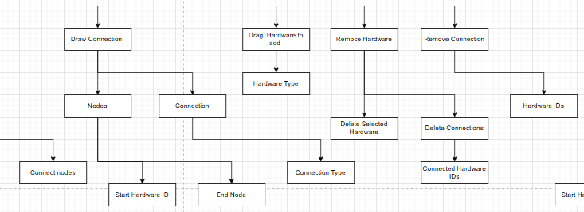
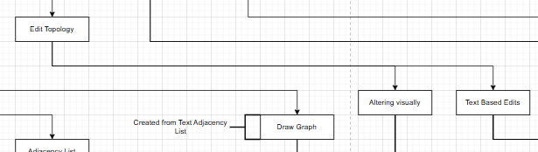
Altering Visually:

Text Edits:

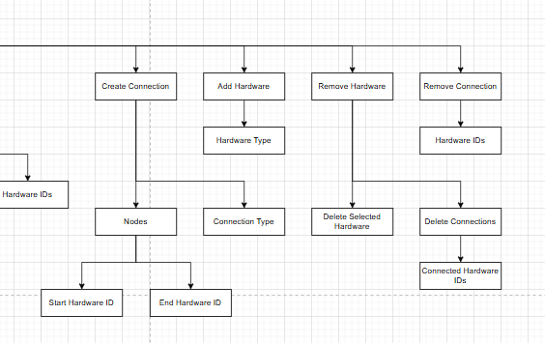
Saving:
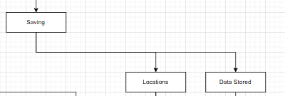
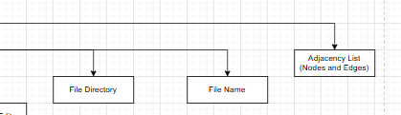
Whole New Topology Section Together:
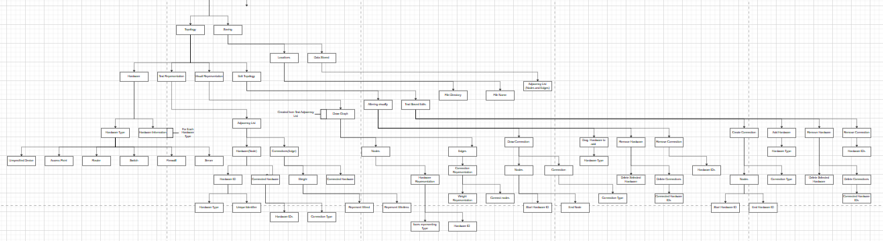

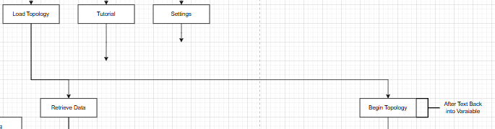
Load Topology Section

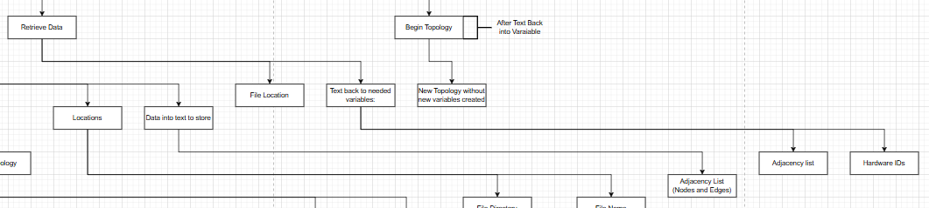
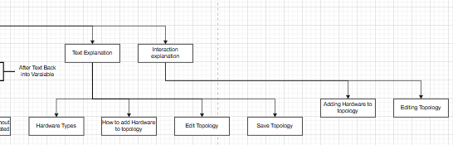
Tutorial Section

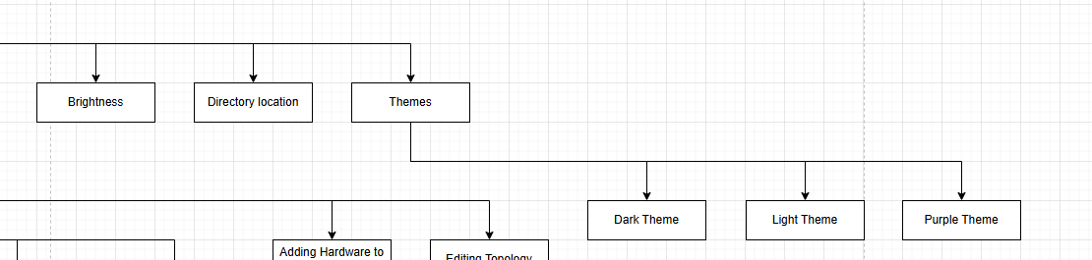
Settings Section

Whole Chart

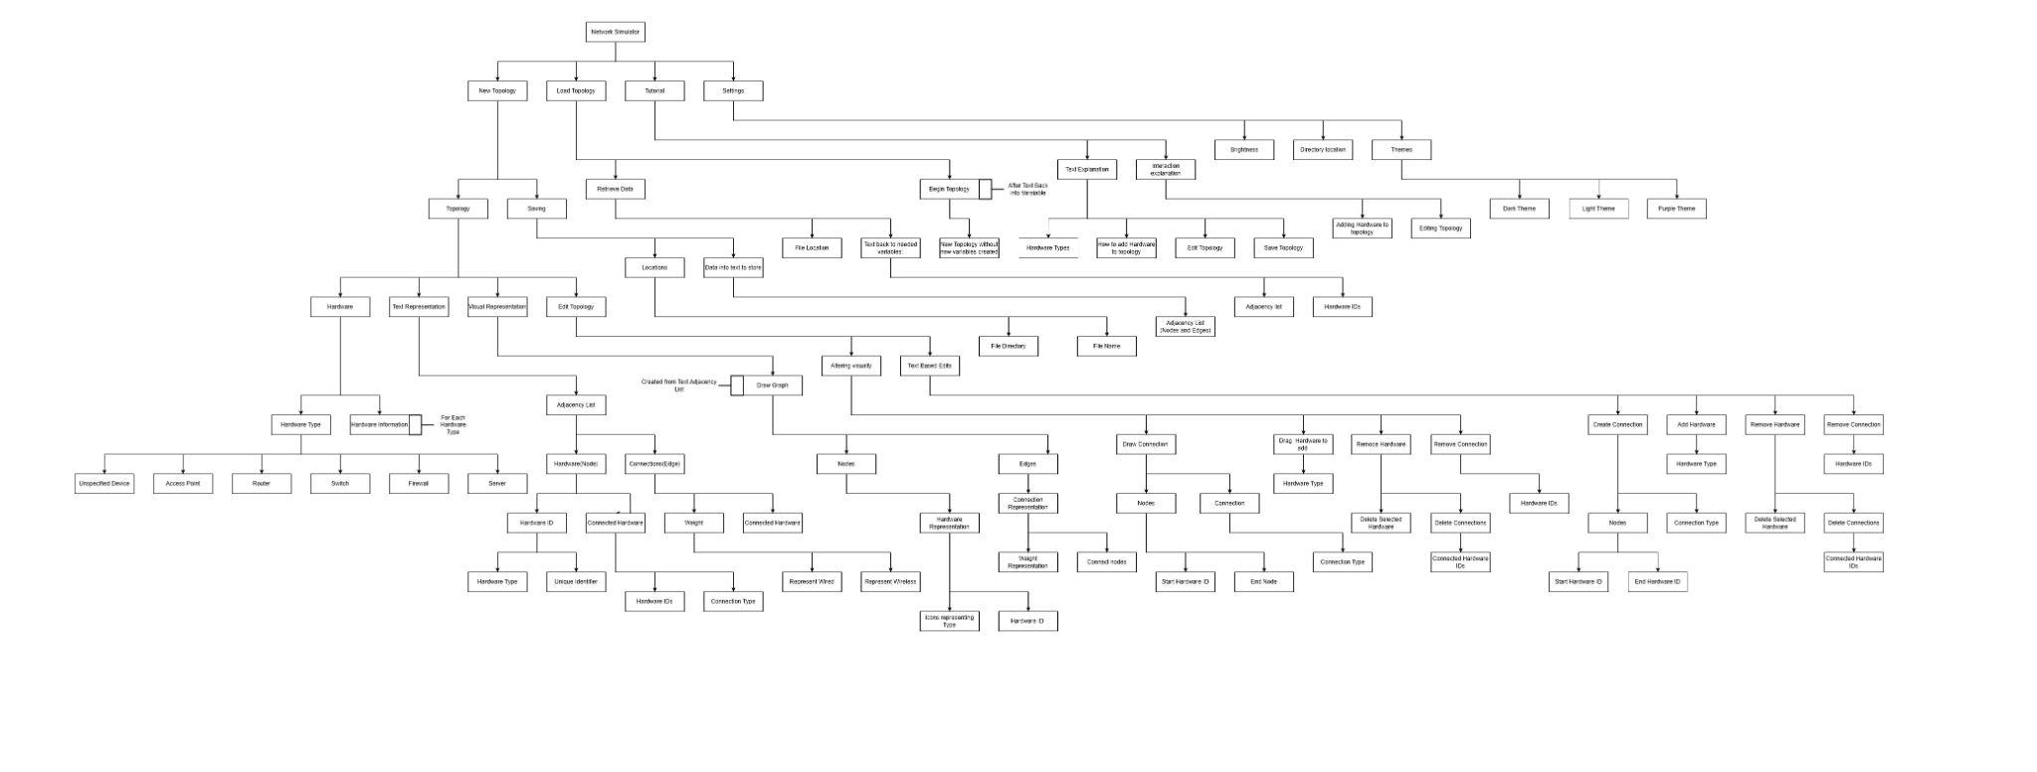

IPSO Chart

Type | Name/Type | Description | Example | Where Needed
Input | Mouse selection(item) | What type of node the user clicks on | selecting the firewall node to place into the sandbox | Sandbox, Tutorial, SetupUI
Input | Mouse selection(Connection) | what type of connection the user creates between nodes or what type of node | selecting a wired connection between 2 devices | Sandbox, SetupUI, Tutorial
Input | Mouse selection(Node) | selection of already placed items nodes for connections and movement on the graph | selecting an icon on the graph to create a connection to another | Sandbox, Tutorial, SetupUI
Input | menu selection | choosing between the tutorial, saved and new topologies | clicking on what type of activity you want to do | SetupUI, Tutorial, Sandbox, SavedSandbox
Input, Process | return to menu | returning to menus so a different menu can be selected | clicking on an arrow to return to the menu selection area | SetupUI, Tutorial
Input, Storage | file creation name | naming a file which is being saved so that work can be stored and returned to | naming a file topography to be able to find it later | Save, SetupUI, SavedSandbox
Input, Storage | file selection | sourcing the data from saved files so that work can continue on previous topologies | selecting a file so that older topologies that are saved can be accessed | Save, SavedSandbox
Output | showing topology | icons for different nodes and showing different connections in the sandbox area | the server has a specific icon | SetupUI, Tutorial, Sandbox
Output, Input, Process | showing icons for selection | having a menu where hardware can be selected to be placed on the topology | selecting the server icon from the sidebar | Tutorial, SetupUI, Sandbox
Output, Process | moving around sandbox | zooming in and out and moving around the sandbox area to have larger topologies and view more of it at once | zooming out of the graph to view the full topology | Sandbox, Tutorial
Output, Process | grid view on the sandbox | sandbox area having the optional choice for visible grid | checkbox for the grid so that the area can be neat | Sandbox, SetupUI, Tutorial
Output, Process | tutorial finish | when the tutorial ends a new sandbox is created for the user | closing or ending the tutorial and a new sandbox being created | Sandbox, Tutorial, SetupUI
Process | Mouse Coordinates | where the mouse is relative to the sandbox, what is being moved where | finding the position of where the mouse is on the graph for user interactions(not given by user) | Sandbox, SetupUI, Tutorial
Process, Output | tutorial | showing the tutorial on how to use the program when selected | presenting instructions with highlighted areas showing where and small boxes with how the user | SetupUI, Tutorial
Process, Output | setting up a new sandbox | after selecting the new topologies menu and switching to a new screen with a sandbox area | creating a blank area where the sandbox can be created | SetupUI, Sandbox
Process, Output | setting up saved sandbox | after selecting which file to use for saved topology, reloading from the data | selecting the topology file to load the topology created the last time the program was run | SetupUI, SavedSandbox
Process, Storage | collecting data from a file | collecting the data from a selected save file so that older topologies can be run | sourcing the data such as node coordinates and connections from the selected file | SavedSandbox, SetupUI, Save
Process, Storage | storing data in a file | storing all the data required to reload and access the file later in un the process | putting the data from the running topology and storing it in a file | Save, SavedSandbox
Process, Storage | processing saved data | after collecting the data, processing it so it's easy to use | cleaning the data so it's stored in easy-to-use arrays, lists and suchlike from the file | SetupUI, SavedSandbox
Process, Storage | storing as graph | from connection and node coords saving the data as a graph | node3@(31,14) is connected to node 6@(12,32) with a wired connection | SetupUI, Sandbox
Process, Storage, Output | storing connections | using weight between connections to | connection is wired so has a weight of one presented as a solid line | Sandbox, SetupUI
Storage, Input | storing node co-ords | when a new node is placed, storing the coordinates so objects cannot overlap on top of one another | a node at(31,14) so that no more nodes can be placed there unless are removed | Sandbox, SetupUI
Storage, Process | storing topologies | storing topologies in an easy-to-access file close to the program-run file | having a topology file in the program folder | Save, SavedSandbox
Storage, Process | file overwriting | the changing of saved files after edits have been made, resaving after wiping | editing a file after being saved before so that the next save is made | Save, SavedSandbox, SetupUI

Data Dictionary

Field Name | Data Type | Data Format | Field Size | Description | Example
Selected_Node | String | "Hardware Type" | 1 | what type of node the user has selected | "Server
Mouse_Coord | integer | (xx, yy) | 2 | where the user has their mouse positioned to the nearest point on the grid | (13,0)
Network, Graph | Adjacency list |  |  | Storage of the topology of the network graph, with cost and nodes.
Selected connection | integer | 1 | 2 | the cost of whether it's a wired or wireless connection to apply to the graph
Menu selected | integer | 1 | 4 | which menu has been selected using an integer to represent which one it was
return | Queue | (last process, process before, etc | 10 | ability to go back on past ten actions one by one | ("c",4.CntrlV)
File Name(New) | string | "Name" |  | the name for the file wanted to be saved to | "Topology2"
file selection | string | "Wanted File" |  | the name of the file wanted by the user which stored their topology | "Topology1"

Interface Design
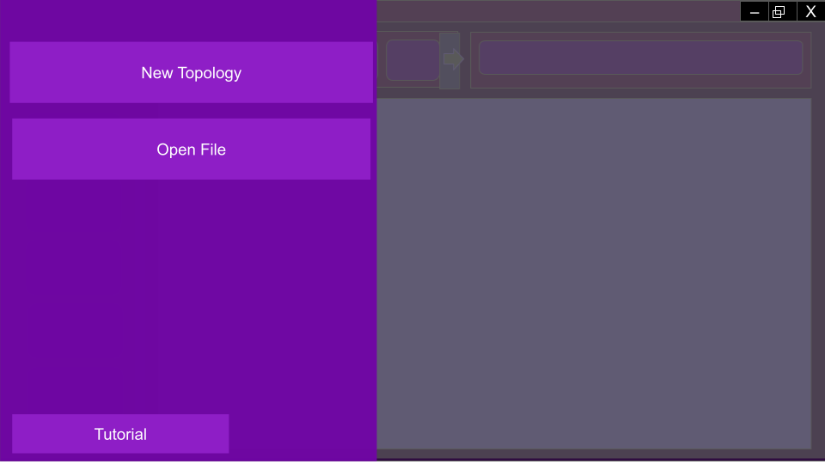
This shows the screen when a user has no topology selected(in use) or has first opened the application. I have decided to have easily visible buttons and a simple design for users' first interaction when opening the application. As well as this, the option for the tutorial allows users to access a helpful walkthrough whilst being placed out of the way for returning users.

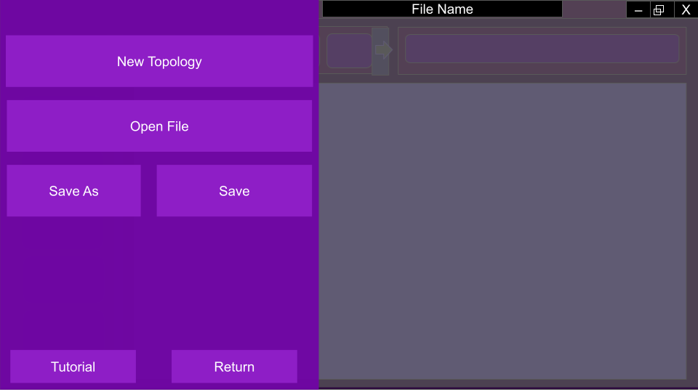
This screen shows when a user has a topology open with the ability to return to the sandbox screen, save the file in a location, or start a new topology.
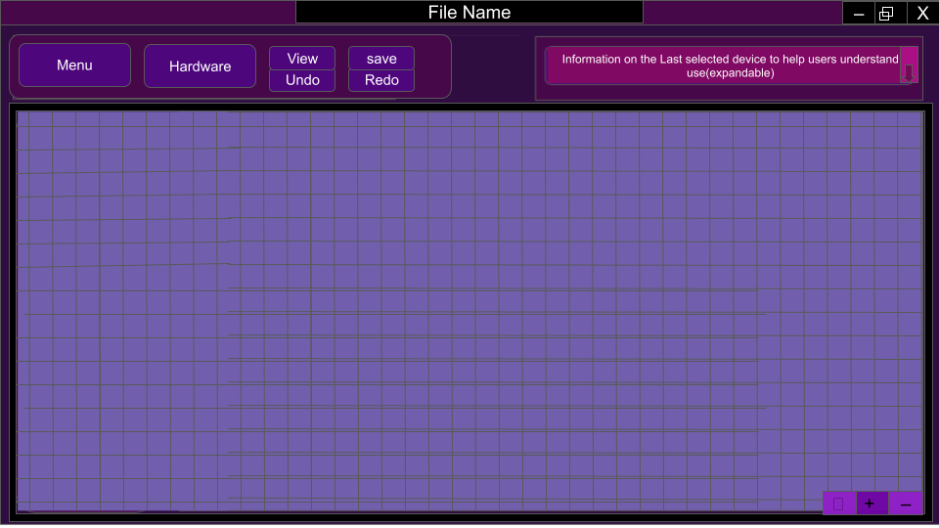
This is the screen for viewing the topology as a whole. The user can zoom in and out, and the information on the last selected hardware is at the top right. The menu selection bar also offers quick save undo and redo options. The use of a grid in the sandbox aims to help organize the topologies created by the user.
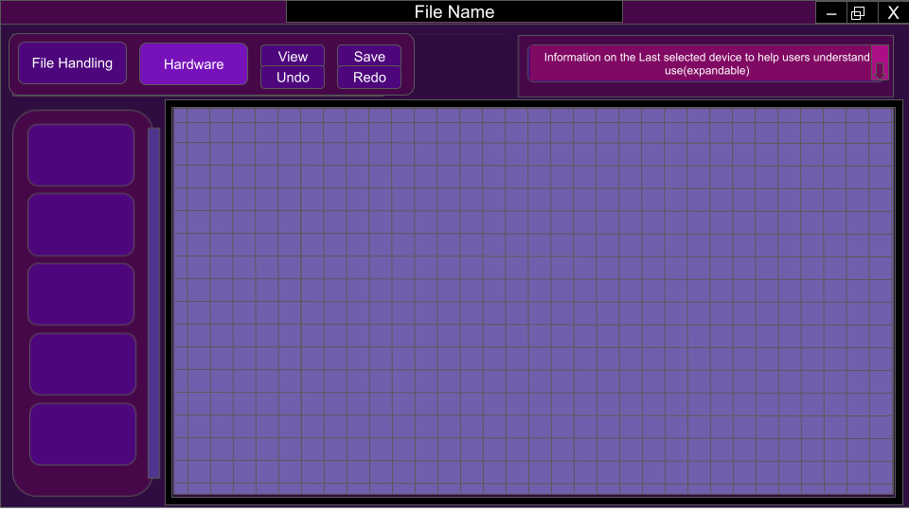
This screen shows when users select the hardware menu with it being present on the left, reducing the size of the sandbox but allowing an easy view of each option the user can add to their network.

UML Diagram
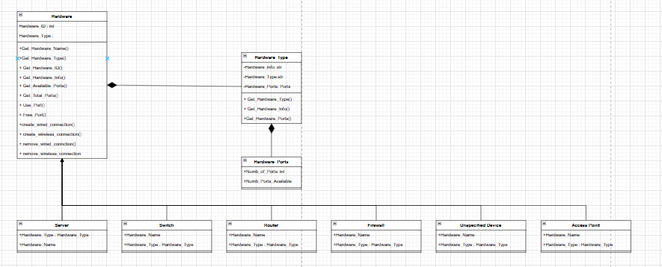
:
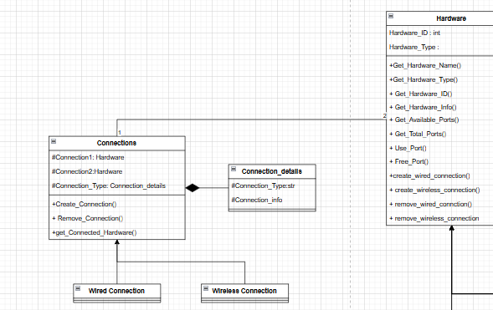
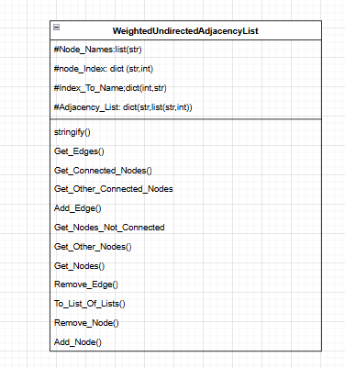

Flowchart
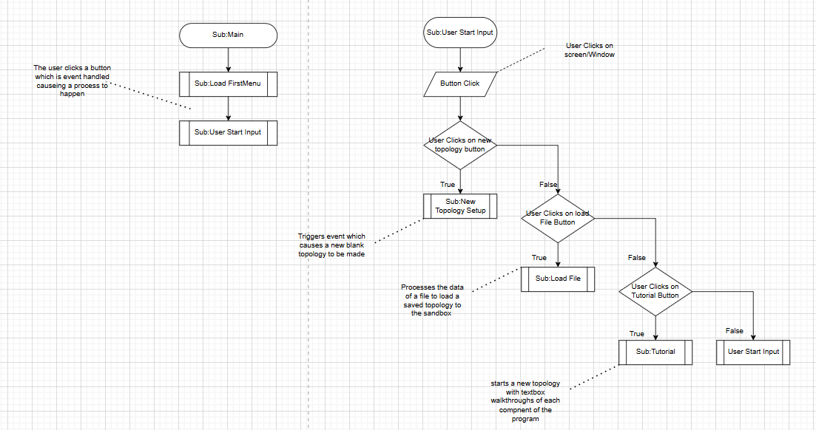
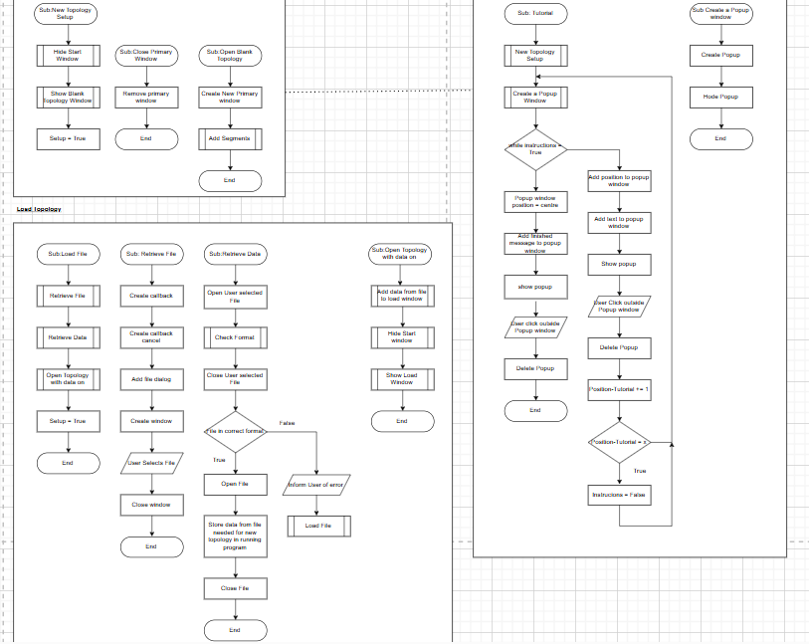

Development:
All code can be found in the appendix with the name of the file as the heading for each section of code or on my github.
https://github.com/L-V0113r/NEA---Topology-Blueprinter

Main
Main - This function runs Start_Program from the file” intro_screen” to begin the program.

Main_Menu
Get_Viewport_Size - This function returns the dimensions(width and height) of the viewport that is currently in use.
Main_Window - This function creates a window to the size of the viewport and uses the function “Menu_Buttons” to add buttons to this window. it gets the data for the buttons from the function “Button_Data”
Button_Data - returns the data required for the buttons to be created
Menu_Buttons - calculates spacing for equal button placement on the screen then creates the buttons
Setup_Viewport - creates the main viewport ,maximizes it and begins the render loop
Start_Program - compiles the functions in “intro_screen” to run in the correct order

Tutorial
Tutorial_Begin - hides the intro screen window then gives the user the option between continuing the tutorial or returning to the intro screen in case they accidentally pressed to load the tutorial.
Tutorial_Begin_Populate - populates the tutorial begin window with appropriate window
Tutorial_Step_1 - presents the selection options given when in the main running of the program that,when an option is pressed,presents an explanation of how it works.Also gives the option to the user to continue to step 2 or to return to the main menu.
Hardware_Selection_Explanation - presents a brief explanation to the user on what the Hardware selection button does.
Edit_Explanation - presents a brief explanation on how to edit the topology you are currently working on.
Save_Explanation - briefly explains how to save the topology currently in use.
Tutorial_Step_2 - presents more in depth explanations on the different hardware available to the user and ways.
Hardware_Presentation - present the user buttons of all the hardware available in the program and when selected the button still shows information for the corresponding hardware.
Info_Window - presents to the user the information from a selected hardware.
Tutorial_Step_3 - Explains how to add hardware to a current topology using “Hardware_Selection_Setup” and “Setup_Variables_And_Constants” to allow users to experiment with how it works.
Tutorial_Step_4 - explains to the user how to edit the topology currently in use.
Fake_Adjacency_Hotbar_Editor - demonstrates what editing the properties of a device looks like.
Finish_Tutorial - deletes all the tutorial windows that could be open and returns to the intro screen/main menu

File_Handling
Globalise_Current_File_Location - globalises the current file location so that it can be easily checked when saving
Convert_Dict_To_String - converts the values and key of a dictionary into a string so that it can be stored on a txt file
Check_File - check to make sure the name of a file input is acceptable to be saved eg:doesn't contain .txt as that would affect how it is saved
Save_As - writes a dictionary to a .txt file in a directory which accompanies the code
Get_Current_File - returns the current file name
Update_Dictionary - overwrites a file that already has text in with the dictionary
Confirm_Overwrite - checks with the user before overwriting the file or allows them to change their mind
Overwrite_File - overwrites the file after the user confirms there will to do so
Load_File_Text - Gets the location of the file the user want to use when loading a topology
Get_Files_In_Directory - returns all of the files in a specific directory
Load_Contents - retrieves the text from a selected file
Convert_String_To_List - converts a string into a list using ast to give the string its literal value
Clean_Txt - removes empty lines and whitespace from the text
Variable_Dict_To_Globals - returns the saved globals from a loaded file and returns them to globals to be accessed easier in the program
Compiles the functions required to turn the stored string into all of the globals required to reload an old topology
Load_File - begins the process of finding the users wanted file to load
Globalise_Variables-turns a list of lists into their individual global variables
Hardware_Name_List_Load - creates the hardware name list global variable from the saved information in the file
Load_Used_Ports - adds to the recreated hardware the number of connections used by that piece of hardware
Check_Hardware_To_Load - Checks which piece of hardware form the list is being created for the Adjacency List
Get_Stored_Nodes - returns a list of all the nodes stored in the list of information retrieved from the file
Connect_Nodes_From_List - Connects together the nodes in the adjacency list based off of the retrieved information
Confirm_Load - Confirms with the user that this is the file they wish to load
Continue_Load - allows the topology to be loaded in the correct setup so that the global variables loaded aren't overwritten during the setup
Cancel_Load - returns to the main menu

Topology_Creator
Menu_Buttons - evenly positions and creates the buttons needed in the menu taskbar at the top of the creator
Menu_Buttons_Selection - returns the button data as a local variable
Menus_Setup - sets up the menus taskbar at the top of the screen giving the information of the button functions
Hardware_Selection_Setup - sets up the hardware_Selection_Window if it is not open already,else it closes
Hardware_Selection_Window - creates the window then uses Hardware_Selection_Buttons to populate the window with the correct buttons
Hardware_Selection_Buttons - populates the Hardware selection window with buttons each with their own function
Hardware_Selection_Buttons_Functions - checks the required windows are open and opens or closes them
Hardware_Selection_Info_Window - creates the window which presents hardware information then populates it using the hardware type as a key in the global variable Hardware_Selection to then get the information on that type of hardware
Check_Hardware_To_Add - checks the type of hardware the user has selected to add to their topology then adds it
Add_Hardware_To_Adjacency_List - updates all the variables that change when a new piece of hardware is with the new data.has a specific exception for when the hardware is “Unspecified_Device”
Not_Unspecified_To_Adjacency_List - confirms if the user wants to add the device to the Adjacency_List
Unspecified_To_Adjacency_List - gets the number of ports on the device and checks if the user wants to add the device to the adjacency list
Hardware_Into_List - adds the Hardware to the Adjacency _List and updates the window that presents to the user the adjacency list
Update_Adjacency_Hotbar - Updates the Adjacency_Hotbar window
Adjacency_Hotbar_Setup - initializes the Adjacency List and sets up the window which presents it
Populate_Hotbar_Editor - places all the required buttons onto the hotbar editor etc.
Adjacency_Hotbar_Editor - creates the window to edit the adjacency_List and provides the user to add or remove connections as well as remove pieces of hardware
Edit_Hardware - creates the edit hardware window which allows the user to alter properties of a selected hardware. Also presents the current properties of the selected hardware
Refresh_Edit_Window - refreshes the edit hardware window with the most up to date data
Check_Hardware_To_Add_Connection - gets the id number for each both selected hardware taking part in the connection
Check_Hardware_To_Remove_Connection - checks the hardware that is selected and removes the connection from both objects
Add_Connection - creates a connection between 2 different hardware with a specific weight which allows the user to understand whether the connection is wired or wireless
Confirm_Connection_Callback - gets the data required to add a connection then fulfills the request
Correct_Connection_Check - checks to make sure hardware is connected to the correct other hardware
Remove_Connection - creates a window which confirms the connection the user wants to remove
Confirm_Removal_Callback - confirms the removal of the connection
Get_Ports = returns the amount of ports available on a specific hardware
Setup_Variables_And_Constants - sets up the global variables and constants required when first loading the program
New_File_Run - begins the running of a new topology
Get_Hardware_Selection - returns the dictionary that shows the hardware types and their information
Return_To_Main_Menu - returns the user to the main menu
Confirmed_Return_To_Main_Menu - returns the user to the main menu,clears all in use windows
Collate_Variables - collates all the variables needed to save the file
Clear_New_File_Viewport - deletes all possible windows that could be open at the time in the topology creator and clears the global variables
Loaded_Setup - loads the correct variables required when loading an old topology into the topology creator
File_Details - gets the user to input the file name that will be used to save the file

Nodes
Load_Adjacency_List - uses the adjacency list to get the nodes and connections of nodes and creates the object for them on the node editor
No_connection - passes so that when a connection is attempted on the nodes nothing happens
Connect_nodes_from_Adjacency_List - connects the nodes on the graph as they are connected in the adjacency list
Add_nodes_from_adjacency_list - adds the nodes from the adjacency list onto the graph as objects
Reset_Visuals - deletes all objects used on the graph so that every time the topology is represented visually there are no errors
Create_visual_representation- compiles all the nodes functions to present to the user an intractable topology

Adjacency_Storage
WeightedUndirectedAdjacencyList
Name | Purpose
add_node | Adds a node to the adjacency list
remove_node | Removes a node from the adjacency list
list_of_lists | Converts the adjacency list into a list of lists with all the information required to store and load without losing information
add_edge | Adds an edge between two nodes
remove_edge | Removes a connection between 2 nodes
get_nodes | Returns a list of all the nodes
get_other_nodes | Returns all the nodes except from one selected node
get_edges | Gets all the connections of a selected node
__str__ | String representation of the adjacency list

Hardware_Objects

Hardware
Name | Purpose
Get_Hardware_Name | Returns the name of the hardware
Get_Hardware_Type | Returns the type of hardware
Get_Hardware_ID | Returns the id of the hardware
Get_Hardware_Info | Returns the information about the hardware type
Get_Available_Ports | Returns the number of ports available on the hardware
Get_Total_Ports | Gets the total number of ports on the piece of hardware,in use and available
Use_Port | Changes the number of ports available in the hardware
Free_Port | This method frees a port on the hardware by removing one of the connection
create_wired_connection | Creates a wired connection object between 2 hardware devices
create_wireless_connection | Creates a wireless connection between 2 devices
remove_wired_connection | Removes the connection of the 2 devices
remove_wireless_connection | Removes the connection of the 2 devices
change_wired_connection | Changes one of the ends of the 2 devices
change_wireless_connection | Changes the 2 connected devices

Connections
Name | Purpose
Get_Connection_Type | Returns the type of connection
Get_Connected_Hardware | Returns the devices that are connected
Get_Connection_Info | Returns the information of the type of connection
Create_Connection | Uses the ports of 2 different selected hardware
Remove_Connection | Frees the ports used by the connection
Change_Connection | Changes one of the devices the connection is between

Testing:

Objective No | Objective | Test and data | pass/fail | evidence
1.1/2 | When starting the application a Main Menu is presented | Acceptable,open application | pass | https://youtu.be/9yo_6qCtwPE
2.1.1 | Pressing the new file button it takes the user to the new file/new topology screen | Acceptable,new file button | pass | https://youtu.be/69X97muy95s
2.1.4 | Pressing the Load File button it takes the user to begin loading a file | Acceptable,load file button | pass | https://youtu.be/HxmpVHZ3060
2.1.2 | Pressing the Tutorial Button it takes the user to the beginning of the tutorial | Acceptable,tutorial button | pass | https://youtu.be/Cb7gLw8m95k
2.1.3 | When pressing the Settings Button it takes the user to the settings menu | N/A | Fail | incomplete
3.1.1 | Settings button which takes the user to the settings screen | N/A | Fail | incomplete
3.1.2 | Press Main Menu button which takes the user back to the main menu screen | Acceptable,main menu button | pass | https://youtu.be/SG7CPQFFGNM
3.1.3 | Pressing the Save button starting the save process | Invalid,  No topology started so cannot save | pass | https://youtu.be/fMvHMaHdH0A
3.1.3 | Pressing the save button to start the saving process | Valid,one hardware on the topology meeting the requirements | pass | https://youtu.be/QTp66jlT3fw
3.1.4 | Hardware Selection button that presents the hardware selection menu | Acceptable,hardware selection button | pass | https://youtu.be/bzABRj3S9Ps
3.1.5 | Edit button that presents the edit menu to the user | Invalid,if there is no hardware in the topology you cannot edit anything | pass | https://youtu.be/vJq--H7G-DI
3.1.5 | Edit button that presents the edit menu to the user | Valid, one hardware on the topology meeting the requirements to edit the topology | pass | https://youtu.be/5ZnS1pSCeps
3.2.1.1.1/  3.5.1.1 | Router button,which when selected provides the user with the option to add it to the topology and presents information about the hardware in the hardware information window | Acceptable,added router to topology(adjacency list) | pass | https://youtu.be/yJ0rUPmeYzY
3.2.1.1.2 | Cancel adding a router to the topology | Acceptable,cancel button | pass | https://youtu.be/ifbe5hH4qBU
3.2.1.2.1/  3.5.1.2 | Switch button,which when selected provides the user with the option to add it to the topology and presents information about the hardware in the hardware information window | Acceptable,added switch to topology | pass | https://youtu.be/jdzOEBA7sHQ
3.2.1.2.2 | Cancel adding a switch to the topology | Acceptable,cancel button | pass | https://youtu.be/1fLkzt261JA
3.2.1.3.1 | When selected ,the add window also has an input to receive how many ports on the unspecified device | Acceptable ,selected specific number of ports to the | pass | https://youtu.be/PUzct6P5Qd8
3.2.1.3.1.1 | The number of ports on the unspecified device is added and stored with the device | Borderline,100 port hardware  0 port hardware | pass | https://youtu.be/y2wx-ZEPAZU
3.2.1.3.2/  3.5.1.3 | Unspecified device button,which when selected provides the user with the option to add it to the topology and presents information about the hardware in the hardware information window | Acceptable,added unspecified device to topology | pass | https://youtu.be/adl9ec_cRd4
3.2.1.3.3 | Cancel adding an unspecified device to the topology | Acceptable,cancel button | pass | https://youtu.be/M2dcoffS5pw
3.2.1.4.1/  3.5.1.4 | Access point button,which when selected provides the user with the option to add it to the topology and presents information about the hardware in the hardware information window | Acceptable,added an access point to the topology | pass | https://youtu.be/2vGLL_yhWdA
3.2.1.4.2 | Cancel adding an access point to the topology | Acceptable,cancel button | pass | https://youtu.be/N7Uwhfoa-R4
3.2.1.5.1/  3.5.1.5 | Server button,which when selected provides the user with the option to add it to the topology and presents information about the hardware in the hardware information window | Acceptable,added a server to the topology | pass | https://youtu.be/yHXy1bRVpW0
3.2.1.5.2 | Cancel adding a server to the topology | Acceptable, cancel button | pass | https://youtu.be/Ye2p5PdvRU0
3.2.1.6.1/  3.5.1.6 | Firewall button,which when selected provides the user with the option to add it to the topology and presents information about the hardware in the hardware information window | Acceptable, added a firewall to the topology | pass | https://youtu.be/lrzv39kq54M
3.2.1.6.2 | Cancel adding a firewall to the topology | Acceptable,cancel button | pass | https://youtu.be/Ofp2ojZ0VCM
3.3.1.1.1 | On the edit menu,allow the user to create a “wired” connection between 2 selected hardware devices | Acceptable,testing for each different type of hardware with each different type. | pass | https://youtu.be/uENgv4r_51I
3.3.1.1.2 | On the edit menu,allow the user to create a “wireless” connection between 2 selected hardware devices | Acceptable,testing for each different type of hardware with each different type. | pass | https://youtu.be/O5-NqQ0zY9g
3.3.1.2 | On the edit menu,the ability to remove a connection between 2 selected devices | Acceptable,remove a connection from each type of device | pass | https://youtu.be/bE67hWK689k
3.3.1.3 | On the edit menu the ability to remove a device and all of its connections | Acceptable, removing each type of device with at least one connection or no connections on each type | pass | https://youtu.be/880kFgMw_Y8
3.3.2 | On the edit menu, present the user with properties of the selected hardware | acceptable | pass | https://youtu.be/b4blf978T20
3.4.1 | Sandbox icons for different hardware types | incomplete | fail | N/A
3.4.2 | Allow the user to drag and drop the hardware icons on the topology to move them to wanted locations | Partially complete, users can drag around the hardware to reposition them on the topology but hardware aren't represented by icons | pass | https://youtu.be/QZI9tm-BNLc
3.4.3 | Show appropriate types of connections between connected hardware: | Can show connections between hardware but cannot show different types of connection | pass | https://youtu.be/sV6Fn7itnj8
3.4.4.1 | Zoom in on the topology |  | fail
3.4.4.2 | Zoom out of the topology |  | fail
3.4.4.3 | Move around the topology | Move around the topology | pass | https://youtu.be/Y6PPMAoS55g
3.6 | Save process | Acceptable,filename input then viewing where it is stored | pass | https://youtu.be/SQ5d1g5zi1M
3.6 | Save process | borderline?
4.1.1.1 | Interaction for adding hardware to the topology to learn in the tutorial | Adding hardware to the tutorial topologies as instructed | pass | https://youtu.be/6QAvRdvazXU
4.1.1.2 | Interaction for saving a topology to learn in the tutorial |  | fail
4.1.1.3 | Interaction for editing a topology to learn in the tutorial |  | fail
4.1.2.1 | Information on the hardware selection and how the hardware selection window works in the tutorial | Acceptable,viewing the different information in the tutorial | pass | https://youtu.be/QxeMJ9Iqze0
4.1.2.2 | How to save a file informed in the tutorial | Acceptable,viewing the different information in the tutorial | pass | https://youtu.be/XmHTUHQKeB0
4.1.2.3 | How to edit the topology informed in the tutorial | Acceptable,viewing the different information in the tutorial | pass | https://youtu.be/kuKgwJQzLkg
4.1.3 | Use images to better show the user how to use the program | N/A incomplete | fail
5 | Settings screen with option such as brightness or theme | N/A incomplete | Fail
6.1.1 | Cancel loading a file and returning to a main menu | Acceptable.cancel loading a file | pass | https://youtu.be/vszJca5MxR8
6.1.2/6.2 | Select a file from the folder to open,which takes the user to the new topology screen and loads the variables | Acceptable, selecting a file and opening | pass | https://youtu.be/voJaegpPF7Q
 | General test | Testing all the features in one run through |  | https://youtu.be/J5v48NzQrg4

Evaluation:

#####3rd november end

- Objectives i have done particularly well on #### bragging chance–saving and loading the file and using an object to store the topology
- Objectives not done particularly well - WHY!!!!!!!! Honesty,sandbox-hard to implement
- If i was to revisit the project what would i do differently,(particularly development)
- End user feedback #####present-what feedback /transcription/email and comment

Overall i think that the project was a success with most objectives being completed .

One objective i believe i did particularly well on was the storage of the graph through an adjacency list object.i think this was a success as not only was it space efficien it was extremely easy to implement adding nodes and update the view when a change was made.Furthermore, the object based storage allowed me to scale the networks

One objective i would like to have improved was the storage of files. It was a frequent issue that if the name inputted by the user were the same as a previous file that the old file would be overwritten without warning .My end user feedback also agreed with this” The file handling can be a bit funky, if you use the same name as another topology the old topology gets overwritten making you lose topologies if you forget . . . ”. With this in mind, if i was to do this project again i would of been sure to add a confirmation or a check to make sure the filename being created wasnt already in the directory.

Also following my end user feedback, if i was to do the project again i would of used another library to handle the graph generation as using dearpygui made the visualization hard as it was difficult to determine where the edges were and all the nodes bunched up leading to hard visualizations.Furthermore the avility to add icons was a limiting factor of the library meaning that my nodes were indistinguishable apart from there names making it difficult when there was a large topology to find the required nodes.

Another objective i believe i did particularly well on was the loading of files.I was particularly proud of this as the process of changing the text back into global variables was especially hard as i had to use the is module to get the filenames for the user to choose then cleaning the data from the files and getting back the adjacency list from the file.

Appendix:

End User Feedback Transcript

Interview:Analysis of my projects technical solution
Interviewee name: Jacob Jalban (Computer science Student)
Date:20/10/2025
Correspondance Method: Inperson
Recording Method:Written

8:32 AM
Lucas - After using my program for a while what are your general thoughts on the project overall?

Jacob - My first impression was that its very straightforward to understand .The use of an adjacency list to show the topology whilst editing made the structure of the topology easy to understand. . . it felt logical too put the topology together .

Lucas - Did you use the tutorial before you started your first topology or did you go straight into the main features?

Jacob - i had a brief look at the tutorial but it quickly became hard to understand as the different windows overlapped and blocked each other.

Lucas - Was the Interactive aspect of the tutorial easier to understand than the example based?

Jacob - There wasnt much difference if im honest, the interaction might make it easier to remember but by the time you start actually using the program its logical enough to understand anyway.

Lucas - Was there any need for a Tutorial then?

Jacob - i think its a nice feature if you struggle with the software to get a better understanding but i found it unnecessary as it wasnt that hard to grasp how to use the software in the first place.

Lucas - Speaking of the topology ,How was the visualization aspect for viewing the topology?

Jacob - it was clunky . . . the movement between and the way the nodes generated made it hard to understand or interpret. Not only would the edges of the nodes overlap making it seem like one connection .it was also hard to distinguish the other nodes from each toher.They were named but this was the only distinguishing feature of them, if they were different colours or shapes it would of been easier to tell which hardware was which when visualizing.

Lucas - Editing was limited to only on the Text Adjacecny list. Would it have been easier to use if the editing was available in the visualization ?

Jacob - yes but only to a point because when the network got too big visualizing the connections on the graph made it harder to understand because the nodes and connections clustered.

Lucas - was there any other issues or good features you found that we havent spoken of yet?

Jacob - The file handling can be a bit funky, if you use the same name as another topology the old topology gets overwritten making you lose topologies if you forget. . . one good aspect though was the fast loading, where you stored it as a text file it made the loading of old topologies very fast with almost no delay.

Lucas - Yes i noticed those file issues aswell, if i did it again i would make sure theres a confirmation between naming and saving the file.

Jacob - the general processes like editing the topology and adding the hardware came naturally once you started using the program aswell ,.

Lucas - do you think there is anything that you would of changed to make the program better?

Jacob - other than the overwriting bug i wished that the visual graph could of been better because i think it just made the whole system more confusing because of the way it layed out nodes.

Lucas - thanks for doing the interview

Jacob - no problem

Code
For my code i had to install the dearpygui library.
The code in the appendix is organised by filename as the title of each heading

For easier access use github: https://github.com/L-V0113r/NEA---Topology-Blueprinter

Main.py

import dearpygui.dearpygui as dpg
from Main_Menu import *

def Main():
Start_Program()

Main()

Main_Menu.py

from Topology_Creator import *
import dearpygui.dearpygui as dpg
from Tutorial import *
from File_Handling import *
from Tutorial import Tutorial_Begin

def Get_Viewport_Size():# Returns the current viewport size
viewport_width = dpg.get_viewport_width()
viewport_height = dpg.get_viewport_height()
return viewport_width, viewport_height

def Main_Window(window_width, window_height):# Creates the intro window with buttons for picking the way that the user wants to start the program
with dpg.window(label="Main Window", tag="main_window", width=window_width, height=window_height, no_resize=True, no_collapse=True, no_move=True, no_close=True) as main_window:
with dpg.group():
Menu_Buttons(Button_Data(), window_width, window_height, 4)
dpg.set_primary_window("main_window", True)

def Button_Data():# Returns a list of button labels and their corresponding callback functions
return [
("New File", lambda:New_File_Run()),#function from New_File.py
("Load File", lambda: Load_File()),#function from File_Handling.py
("Tutorial", lambda: Tutorial_Begin()),#function from Tutorial.py
]

def Menu_Buttons(button_data, window_width, window_height, vertical_spacing):
button_width = window_width // len(button_data)
button_height = int(window_height / (vertical_spacing * 4))
spacing = int((window_height - (len(button_data) * button_height)) // (len(button_data) + 1))
x_position = (window_width - button_width) // 2

for i, (label, callback) in enumerate(button_data):
y_position = int((i + 1) * spacing + i * button_height)
dpg.add_button(label=label, width=button_width, height=button_height, pos=(x_position, y_position), callback=callback)

def Setup_Viewport():
dpg.create_context()
dpg.create_context()
dpg.create_viewport(title='TopologyCreator', width=800, height=600)
dpg.setup_dearpygui()
dpg.show_viewport()
dpg.maximize_viewport()

def Start_Program():
Setup_Viewport()
viewport_width, viewport_height = Get_Viewport_Size()
Main_Window(viewport_width, viewport_height)
dpg.start_dearpygui()

dpg.destroy_context()

Tutorial.py

import dearpygui.dearpygui as dpg
from Topology_Creator import *
from Main_Menu import *

def Tutorial_Begin():
dpg.hide_item("main_window") # Do not delete the main window unless you are replacing it
with dpg.window(label="Tutorial",tag="tutorial_window",width=800,height=600,no_resize=True,no_collapse=True,no_move=True,no_close=True,pos=(600,0)):
Tutorial_Begin_Populate()

def Tutorial_Begin_Populate():
dpg.add_text("Welcome to the Tutorial!")
dpg.add_text("This is a simple introduction to the features of the program.")
dpg.add_button(label="Start Tutorial", callback=Tutorial_Step_1)
dpg.add_button(label="Exit Tutorial", callback=lambda: Finish_Tutorial())

def Tutorial_Step_1():
dpg.delete_item("tutorial_window")
with dpg.window(label="Tutorial Step 1", tag="tutorial_step_1", width=800, height=600, no_resize=True, no_collapse=True, no_move=True, no_close=True,pos=(600,0)):
dpg.add_text("This is the first step of the tutorial.")
#talk about the Menu Hotbar, make the hotbar and present each button by letting each button open a new window with information about the button
dpg.add_text("Here you can learn about the Menu Hotbar.")
dpg.add_text("The Menu Hotbar is located at the top of the window and contains buttons for different actions.")
dpg.add_text("Click on a button to learn more about it.")
dpg.add_button(label="Next", callback=Tutorial_Step_2)
dpg.add_button(label="Back to Main Menu", callback=lambda: Finish_Tutorial())
Menu_buttons_selection = [
("Hardware", lambda: Hardware_Selection_Explanation()),
("Edit", lambda: Edit_Explanation()),
("Save", lambda: Save_Explanation()),]
with dpg.window(label="Menus", width=500, height=100, pos=(0, 0), no_close=True, no_resize=True, no_move=True, no_collapse=True, no_title_bar=True,tag="Menus"):
Menu_Buttons(Menu_buttons_selection, 500, 100, 10)

def Hardware_Selection_Explanation():
with dpg.window(label="Hardware Selection", tag="hardware_selection_window", width=400, height=300, no_resize=True, no_collapse=True, no_move=True, no_close=True, pos=(600,100)):
dpg.add_text("This opens Hardware Selection window.", wrap=380)
dpg.add_text("Here you can select the hardware you want to add.", wrap=380)
dpg.add_text("When selecting a hardware to add to the topology the information about the hardware is also presented in the hardware information window.", wrap=380)
dpg.add_button(label="Close", callback=lambda: dpg.delete_item("hardware_selection_window"))

def Edit_Explanation():
with dpg.window(label="Edit Menu", tag="edit_menu_window", width=400, height=300, no_resize=True, no_collapse=True, no_move=True, no_close=True,pos=(600,0)):
dpg.add_text("This is opens Edit topology window.")
dpg.add_text("Here you can edit the topology you are working on by selecting devices then adding or removing connections.",wrap = 380)
dpg.add_button(label="Close", callback=lambda: dpg.delete_item("edit_menu_window"))

def Save_Explanation():
with dpg.window(label="Save Menu", tag="save_menu_window", width=400, height=300, no_resize=True, no_collapse=True, no_move=True, no_close=True):
dpg.add_text("This is the Save Menu window.")
dpg.add_text("Here you can save your current topology to return to later by inputing the name you wish to save as .",wrap = 380)
dpg.add_text("When saving you must be careful as if the name already exists you will overwrite the existing file.",wrap = 380)
dpg.add_button(label="Close", callback=lambda: dpg.delete_item("save_menu_window"))

def Tutorial_Step_2():
dpg.delete_item("tutorial_step_1")
with dpg.window(label="Tutorial Step 2", tag="tutorial_step_2", width=400, height=500, no_resize=True, no_collapse=True, no_move=True, no_close=True,pos=(600,150)):
dpg.add_text("This is the second step of the tutorial.")
dpg.add_text("Here you can learn about the different Hardware.")
dpg.add_text("Click on a hardware button to learn more about it.")
Globalise_Hardware_Selection()
Hardware_Presentation()
dpg.add_button(label="Next", callback=Tutorial_Step_3)
dpg.add_button(label ="Return to Main Menu", callback=lambda: Finish_Tutorial())

def Globalise_Hardware_Selection():
global Hardware_Selection
Hardware_Selection = {
"Access Point": {"Description": "An access point is a device that allows wireless devices to connect to a wired network using Wi-Fi."},
"Firewall": {"Description": "A firewall is a network security system that monitors and controls incoming and outgoing network traffic based on security rules created by the network administrator."},
"Router": {"Description": "A router is a networking device that forwards data packets between computer networks."},
"Server": {"Description": "In computing, a server is a piece of computer hardware or software that provides functionality for other programs or devices, called clients."},
"Switch": {"Description": "A switch is networking hardware that connects devices on a computer network by using packet switching to receive and forward data to the destination device."},
"Unspecified device": {"Description": "Unspecified device"}
}

def Hardware_Presentation():
with dpg.window(label="Hardware Selection", width=200, height=400, pos=(0, 100), no_close=True, no_resize=True, no_title_bar=False,no_move=True,tag="Hardware_Selection_window",):
for i, hardware in enumerate(Hardware_Selection.keys()):
unique_id = f"{hardware}"
dpg.add_button(label=hardware, tag=unique_id, pos=(0, 50 * (i + 1)), width=200, height=50, callback=lambda h=hardware: Info_Window(h))
def Info_Window(hardware):
if dpg.does_item_exist("Hardware_Info_Window"):
dpg.delete_item("Hardware_Info_Window")
with dpg.window(label="Hardware Info", width=600, height=100, pos=(500, 0), no_close=True, no_resize=True, no_title_bar=False, no_move=True):
dpg.add_text(f"Information about {hardware}:")
dpg.add_text(Hardware_Selection[hardware]["Description"], wrap=580)

def Tutorial_Step_3():
del globals()["Hardware_Selection"]
dpg.delete_item("tutorial_step_2")
dpg.delete_item("Hardware_Selection_window")
dpg.delete_item("Hardware_Info_Window")
with dpg.window(label="Tutorial Step 3", tag="tutorial_step_3", width=500, height=300, no_resize=True, no_collapse=True, no_move=True, no_close=True,pos=(600,450)):
dpg.add_text("This is the third step of the tutorial.")
dpg.add_text("Here you learn how to add hardware to the topology.")
dpg.add_text("Once you click on a hardware button a window will open confirming whether you want to add the hardware to the topology,Try adding some now.", wrap=480)
dpg.add_button(label="Next", callback=lambda: Tutorial_Step_4())
dpg.add_button(label ="Return to Main Menu", callback=lambda: Finish_Tutorial())
setup_variables_and_constants()
Hardware_Selection_Setup()

def Tutorial_Step_4():
dpg.delete_item("tutorial_step_3")
with dpg.window(label="Tutorial Step 4", tag="tutorial_step_4", width=700, height=300, no_resize=True, no_collapse=True, no_move=True, no_close=True,pos=(600,450)):
dpg.add_text("This is the fourth step of the tutorial.")
dpg.add_text("Here you learn how to edit the topology.")
dpg.add_text("You can add or remove connections between devices.", wrap=600)
dpg.add_text("select a device in the drop down of the edit window , then you would proceed by selecting if you wish to create or remove a connection.", wrap=600)
dpg.add_button(label="End", callback=lambda: Finish_Tutorial())
Fake_Adjacency_Hotbar_Editor()

# Fake Adjacency_Hotbar_Editor for tutorial purposes
def Fake_Adjacency_Hotbar_Editor():
with dpg.window(label="Adjacency Hotbar Editor",width=300, height=400, pos=(200, 100), no_resize=True, no_close=True, no_title_bar=False, no_move=True, tag="Adjacency_Hotbar_Editor"):
dpg.add_text("Edit Hardware Properties")
dpg.add_button(label="Add Connection")
dpg.add_button(label="Remove Connection")
dpg.add_text("Hardware Properties:")
dpg.add_text(f"Name: example hardware")
dpg.add_text(f"Type: example") # Display the type of the hardware object
dpg.add_text(f"Available Ports: 100")
dpg.add_text(f"Total Ports: 100")
dpg.add_text(f"ID: ExampleID123") # Example ID, replace with actual ID if available}")
dpg.add_button(label="Close", callback=lambda: dpg.delete_item("Edit_Hardware_Window")) # Close the edit window

def Finish_Tutorial():#deletes all the windows in the viewport and returns to the main menu
if dpg.does_item_exist("tutorial_step_1"):
dpg.delete_item("tutorial_step_1")
if dpg.does_item_exist("tutorial_step_2"):
dpg.delete_item("tutorial_step_2")
if dpg.does_item_exist("tutorial_step_3"):
dpg.delete_item("tutorial_step_3")
if dpg.does_item_exist("tutorial_step_4"):
dpg.delete_item("tutorial_step_4")
dpg.delete_item("tutorial_window")
dpg.delete_item("Hardware_Selection_window")
dpg.delete_item("Hardware_Info_Window")
dpg.delete_item("Adjacency_Hotbar_Editor")
dpg.delete_item("Edit_Hardware_Window")
dpg.delete_item("Hardware_Info_Window")
dpg.delete_item("Adjacency_Hotbar")
dpg.delete_item("Menus")
dpg.show_item("main_window") # Hide the main window to return to the main menu
if dpg.does_item_exist("New_Hardware"):
dpg.delete_item("New_Hardware")

def close_variables_and_constants():
del globals()["Adjacency_List"]
del globals()["Adjacency_Hardware_List"]
del globals()["Hardware_Name_List"]
del globals()["loaded"]

File_Handling.py
import ast
import dearpygui.dearpygui as dpg
import os
import Topology_Creator as nf
import Hardware_Objects as hw
import Adjacency_Storage as adj_store

def Globalise_Current_File_Location(file_name):
global current_file
current_file = file_name

def Convert_Dict_To_String(variable_dict):
variable_string = ""
for key, value in variable_dict.items():
variable_string += f"{key}: {value}\n"
return variable_string

def Check_File(file_name, variables):
file_name = file_name +".txt" # Ensure the file name has a .txt extension
if "." in dpg.get_value("file_name_input"):
with dpg.popup("Error", modal=True):
dpg.add_text("Please do not include file extensions in the file name.")
dpg.add_button(label="OK", callback=lambda: dpg.delete_item("Error"))
elif dpg.get_value("file_name_input") == Get_Current_File():##these elifs are not working
Confirm_Overwrite(dpg.get_value("file_name_input"),variables)

elif (dpg.get_value("file_name_input")+".txt") in os.listdir("NEA/Saved_Topologies"):
Confirm_Overwrite(dpg.get_value("file_name_input"),variables)
else:
Save_As(variables, file_name)

def Save_As(variables, File_Name): # uses x to create a new file. all files will be stored in the storage file(savedTopologies folder that will come with the program.
File_Path ="NEA/Saved_Topologies"
with open(os.path.join(File_Path,File_Name), "w") as f:
f.write(Convert_Dict_To_String(variables))
f.close()
Globalise_Current_File_Location(File_Name)
dpg.delete_item("save_file_window")

def Get_Current_File():
if 'current_file' in globals():
return current_file
else:
return None

def Update_Dictionary(File_Name,variables):
File_Path ="NEA/Saved_Topologies"
variables_string = Convert_Dict_To_String(variables)
with open(os.path.join(File_Path,File_Name), "w") as f:
f.write(variables_string)
f.close()
Globalise_Current_File_Location(File_Name)

def Confirm_Overwrite(file_Name,variables):
with dpg.window(label="Confirm Overwrite", tag="confirm_save_window", width=300, height=200):
dpg.add_text(f"The file '{file_Name}' already exists or the input file name is invalid. Do you want to overwrite it?")
dpg.add_button(label="Yes", callback=lambda: Overwrite_File(file_Name,variables))
dpg.add_button(label="No", callback=lambda: dpg.delete_item("confirm_save_window"))

def Overwrite_File(file_Name,variables):
try:
Update_Dictionary(file_Name,variables)
dpg.delete_item("confirm_save_window")
except Exception as e:
with dpg.popup("Error", modal=True):
dpg.add_text(f"An error occurred while saving the file: {e}")
dpg.add_button(label="OK", callback=lambda: dpg.delete_item("Error"))
dpg.delete_item("confirm_save_window")

def Load_File_Text():
dpg.delete_item("confirm_load_window")
with dpg.window(label="Load File", tag="load_file_window", width=400, height=200, no_resize=True, no_collapse=True, no_move=True, no_close=True):
dpg.add_text("Enter the name of the file to load:")
dpg.add_combo(label="File Name", tag="file_name_input_load", items=Get_Files_In_Directory("NEA/Saved_Topologies"))
dpg.add_button(label="Load", callback=lambda: Load_Contents(dpg.get_value("file_name_input_load")))

def Get_Files_In_Directory(directory):
try:
return [f for f in os.listdir(directory) if os.path.isfile(os.path.join(directory, f))]
except FileNotFoundError:
return []

def Load_Contents(file_name):
dpg.delete_item("load_file_window")
with open(os.path.join("NEA/Saved_Topologies",file_name),"r") as f:
file_content = f.read()
f.close()
Convert_String_To_Globals(file_content)

def Convert_String_To_List(file_content):
variable_dict = {}
lines = Clean_Txt(file_content)
for line in lines:
if ": " in line:
key, value = line.split(": ", 1)
variable_dict[key.strip()] = ast.literal_eval(value.strip())
return variable_dict

def Clean_Txt(file_content):
if not isinstance(file_content, str):
file_content = str(file_content)
lines = file_content.split("\n")
lines = [line.strip() for line in lines if line.strip()] # Remove empty lines and strip whitespace
return lines

def Variable_Dict_To_Globals(variable_dict):
global dictionary
dictionary = variable_dict # Store the entire dictionary globally for reference
list_of_lists = dictionary.get("Adjacency_List")
if list_of_lists is not None:
Globalise_Variables(list_of_lists) # Use .get to avoid KeyError if "Adjacency_List" is not present

def Convert_String_To_Globals(file_content):
variable_dict = Convert_String_To_List(file_content)
Variable_Dict_To_Globals(variable_dict)

# Call the function to continue loading the file after converting the string to globals

def Load_File():
dpg.hide_item("main_window")
Confirm_Load()

def Globalise_Variables(list_of_lists):
global Adjacency_List ,Adjacency_Hardware_List, Hardware_Name_List
Adjacency_Hardware_List = Get_Stored_Nodes(list_of_lists)
Adjacency_List = adj_store.WeightedUndirectedAdjacencyList(Adjacency_Hardware_List)
Hardware_Name_List=Hardware_Name_List_Load(list_of_lists)
Connect_Nodes_From_List(list_of_lists)
Continue_Load()

def Hardware_Name_List_Load(Adjacency_List):
global Hardware_Name_List
Hardware_Name_List = []
for sublist in Adjacency_List:
Hardware_ID = str(sublist[0])
connections_used = len(sublist[1])
hardware_type = Hardware_ID.split("_")[0]
if hardware_type != "Unspecified device":
Check_Hardware_To_Load(hardware_type,Hardware_ID)
Load_Used_Ports(connections_used)
else:
total_ports = sublist[3]
Hardware_Name_List.append(hw.Unspecified_device(len(Hardware_Name_List) + 1, Hardware_Name=Hardware_ID,Total_Ports=total_ports,Available_Ports=total_ports))
Load_Used_Ports(connections_used)

def Load_Used_Ports(used_ports):
Hardware_Number = len(Hardware_Name_List) - 1
for i in range(used_ports):
Hardware_Name_List[Hardware_Number].Use_Port()

def Check_Hardware_To_Load(Hardware_Type,Hardware_ID):
if Hardware_Type == "Access Point":
Hardware_Name_List.append(hw.Access_Point(len(Hardware_Name_List) + 1, Hardware_Name=Hardware_ID))
elif Hardware_Type == "Firewall":
Hardware_Name_List.append(hw.Firewall(len(Hardware_Name_List) + 1, Hardware_Name=Hardware_ID))
elif Hardware_Type == "Router":
Hardware_Name_List.append(hw.Router(len(Hardware_Name_List) + 1, Hardware_Name=Hardware_ID))
elif Hardware_Type == "Server":
Hardware_Name_List.append(hw.Server(len(Hardware_Name_List) + 1, Hardware_Name=Hardware_ID))
elif Hardware_Type == "Switch":
Hardware_Name_List.append(hw.Switch(len(Hardware_Name_List) + 1, Hardware_Name=Hardware_ID))

def Get_Stored_Nodes(list_of_lists):
stored_list = []
for sublist in list_of_lists:
stored_list.append(str(sublist[0]))
return stored_list

def Connect_Nodes_From_List(list_of_lists):
for sublist in list_of_lists:
node1 = str(sublist[0])
for i in range(len(sublist[1])):
node2 = str(sublist[1][i])
weight = int(sublist[2][i])
Adjacency_List.Add_Edge(node1, node2, weight)

def Confirm_Load():
with dpg.window(label="Confirm Load", tag="confirm_load_window", width=300, height=200):
dpg.add_text("Are you sure you want to load a file? This will overwrite the current session.",wrap = 250 )
dpg.add_button(label="Yes", callback=lambda: Convert_String_To_Globals(Load_File_Text()))
dpg.add_button(label="No", callback=lambda: Cancel_Load())

def Continue_Load():
global loaded
loaded = True
variables = [Adjacency_List,Adjacency_Hardware_List,Hardware_Name_List]
nf.Loaded_Setup(variables)

def Cancel_Load():
dpg.delete_item("confirm_load_window")
dpg.show_item("main_window")

Topology_Creator.py

import dearpygui.dearpygui as dpg
import Adjacency_Storage as adj_store
import Hardware_Objects as hw_obj
from File_Handling import *
from Nodes import *

def Menu_Buttons(button_data, window_width, window_height, vertical_spacing):#does the layout
button_width = (window_width - (len(button_data) + 1) * vertical_spacing) // len(button_data)
button_height = window_height // 2
y_position = (window_height - button_height) // 2

for i, (label, callback) in enumerate(button_data):
x_position = vertical_spacing + i * (button_width + vertical_spacing)
dpg.add_button(label=label, width=button_width, height=button_height, pos=(x_position, y_position), callback=callback)

def Menus_Setup():
with dpg.window(label="Menus", width=500, height=100, pos=(0, 0), no_close=True, no_resize=True, no_move=True, no_collapse=True, no_title_bar=True,tag="Selection_Menus"):
Menu_Buttons(Menu_buttons_selection(), 500, 100, 10)

def Menu_buttons_selection():
Menu_buttons_selection = [
("Hardware", lambda: Hardware_Selection_Setup()),
("Edit", lambda: Adjacency_Hotbar_Editor()),
("Save", lambda: File_Details(Collate_Variables())),
("Main Menu", lambda: Return_To_Main_Menu()),
("Visualize", lambda: create_visual_representation(Adjacency_List)),
]
return Menu_buttons_selection
def Hardware_Selection_Setup():
if dpg.does_item_exist("Hardware_Selection_window"):
dpg.delete_item("Hardware_Selection_window")
else:
Hardware_Selection_Window()

def Hardware_Selection_Window():
with dpg.window(label="Hardware Selection", width=200, height=400, pos=(0, 100), no_close=True, no_resize=True, no_title_bar=False,no_move=True,tag="Hardware_Selection_window",):
Hardware_Selection_Buttons()

def Hardware_Selection_Buttons():
Hardware_Selection = Get_Hardware_Selection()
for i, hardware in enumerate(Hardware_Selection.keys()):#this loops through the dictionary by using the index and the key
unique_id = f"{hardware}"
dpg.add_button(label=hardware, tag=unique_id, pos=(0, 50 * (i + 1)), width=200, height=50, callback=lambda h=hardware: Hardware_Selection_Buttons_Functions(h))

def Hardware_Selection_Buttons_Functions(hardware):
if dpg.does_item_exist("New_Hardware"):
dpg.delete_item("New_Hardware")
if dpg.does_item_exist("Hardware_Info_Window"):
dpg.delete_item("Hardware_Info_Window")
Hardware_Selection_Info_Window(hardware)
if not dpg.does_item_exist("Adjacency_Hotbar"):
Adjacency_Hotbar_Setup()
else:
Update_Adjacency_Hotbar()
Add_Hardware_To_Adjacency_List(hardware)

def Hardware_Selection_Info_Window(hardware):
info_window_tag = "Hardware_Info_Window"
if not dpg.does_item_exist(info_window_tag):
with dpg.window(label="Hardware Info", width=600, height=100, pos=(500, 0), no_close=True, no_resize=True, no_title_bar=False, no_move=True, tag=info_window_tag):
dpg.add_text(f"Information about {hardware}:", wrap=580, tag="Hardware_Info_Text")
Hardware_Selection = Get_Hardware_Selection()
info = list(Hardware_Selection[hardware])[0]
dpg.add_text(info, wrap=580, tag="Hardware_Info_Details")
else:
dpg.set_value("Hardware_Info_Text", f"Information about {hardware}:")
info = list(Hardware_Selection[hardware])[0] #
dpg.set_value("Hardware_Info_Details", info)

def Check_Hardware_To_Add(Hardware_Type,ports,Hardware_ID):
if Hardware_Type == "Access Point":
Hardware_Name_List.append(hw_obj.Access_Point(len(Hardware_Name_List) + 1, Hardware_Name=Hardware_ID))
elif Hardware_Type == "Firewall":
Hardware_Name_List.append(hw_obj.Firewall(len(Hardware_Name_List) + 1, Hardware_Name=Hardware_ID))
elif Hardware_Type == "Router":
Hardware_Name_List.append(hw_obj.Router(len(Hardware_Name_List) + 1, Hardware_Name=Hardware_ID))
elif Hardware_Type == "Server":
Hardware_Name_List.append(hw_obj.Server(len(Hardware_Name_List) + 1, Hardware_Name=Hardware_ID))
elif Hardware_Type == "Switch":
Hardware_Name_List.append(hw_obj.Switch(len(Hardware_Name_List) + 1, Hardware_Name=Hardware_ID))
elif Hardware_Type == "Unspecified device":
Hardware_Name_List.append(hw_obj.Unspecified_device(len(Hardware_Name_List) + 1, Hardware_Name=Hardware_ID, Available_Ports=ports, Total_Ports=ports))

def Add_Hardware_To_Adjacency_List(Hardware_Type):
Access_Point_ID = len(Hardware_Name_List) + 1
Hardware_Name = (Hardware_Type + "_" + str(Access_Point_ID))
if Hardware_Type != "Unspecified device":
Not_Unspecified_To_Adjacency_List(Hardware_Type,Hardware_Name)
elif Hardware_Type == "Unspecified device":#if the hardware type is unspecified device, then create a window to add the hardware with a slider for total ports
Unspecified_To_Adjacency_List(Hardware_Type,Hardware_Name)

def Not_Unspecified_To_Adjacency_List(Hardware_Type,Hardware_Name):
with dpg.window(label="New_Hardware", width=300, height=400, pos=(200, 100), no_resize=True, no_title_bar=True, no_move=True, tag="New_Hardware"):
dpg.add_text(Hardware_Type +" Name:")
dpg.add_text(Hardware_Name)
dpg.add_button(label="Add " + Hardware_Type, callback=lambda: [Hardware_Into_List(Hardware_Type,0,Hardware_Name), dpg.delete_item("New_Hardware")])
dpg.add_button(label="Cancel", callback=lambda: dpg.delete_item("New_Hardware"))

def Unspecified_To_Adjacency_List(Hardware_Type,Hardware_Name):
Access_Point_ID = len(Hardware_Name_List) + 1
with dpg.window(label="New_Unspecified_Device", width=300, height=400, pos=(200, 100), no_resize=True, no_title_bar=True, no_move=True, tag="New_Hardware"):
dpg.add_text("Unspecified Device Name:")
dpg.add_text(Hardware_Name)
slider_tag = f"Unspecified_Device_Total_Ports_{Access_Point_ID}"
dpg.add_slider_int(label="Total Ports", default_value=10, min_value=1, max_value=100, tag=slider_tag)
dpg.add_button(label="Add Unspecified Device", callback=lambda: [Hardware_Into_List(Hardware_Type, dpg.get_value(slider_tag),Hardware_Name), dpg.delete_item("New_Hardware")]) # Pass the value of the slider and close window
dpg.add_button(label="Cancel", callback=lambda: dpg.delete_item("New_Hardware"))

def Hardware_Into_List(Hardware_Type,Ports,Hardware_Name):
Check_Hardware_To_Add(Hardware_Type,Ports,Hardware_Name)
Adjacency_Hardware_List.append(Hardware_Name)
Adjacency_List.Add_Node(Hardware_Name)
Update_Adjacency_Hotbar()

def Update_Adjacency_Hotbar():
if dpg.does_item_exist("Adjacency_Hotbar"):
dpg.delete_item("Adjacency_Hotbar")
with dpg.window(label="Adjacency List", width=600, height=400, pos=(500, 100), no_resize=True, no_close=True, no_title_bar=False, no_move=True, no_collapse=True, tag="Adjacency_Hotbar",horizontal_scrollbar=True):
dpg.add_text(Adjacency_List.__str__())

def Adjacency_Hotbar_Setup():
global Adjacency_List
Adjacency_List = adj_store.WeightedUndirectedAdjacencyList(Adjacency_Hardware_List)
with dpg.window(label="Adjacency List", width=600, height=400, pos=(500, 100), no_resize=True, no_close=True, no_title_bar=False, no_move=True, no_collapse=True, tag="Adjacency_Hotbar"):
Adjacency_text = Adjacency_List.__str__()
dpg.add_text(Adjacency_text)

def Populate_Hotbar_Editor():
dpg.add_text("Select Hardware:")
dpg.add_combo(label = "", items=Adjacency_List.Get_Nodes(), width=180, tag="hardware_combo")
dpg.add_button(label="Edit Hardware", callback=lambda: Edit_Hardware(dpg.get_value("hardware_combo")))
dpg.add_text("Warning: Removing hardware will delete all connections associated with it.")
dpg.add_button(label="Remove Selected Hardware", callback=lambda: [Adjacency_List.Remove_Node(dpg.get_value("hardware_combo")), Update_Adjacency_Hotbar(), dpg.delete_item("Adjacency_Hotbar_Editor")])
dpg.add_button(label="Close", callback=lambda: dpg.delete_item("Adjacency_Hotbar_Editor"))

def Adjacency_Hotbar_Editor():
try:
if dpg.does_item_exist("Adjacency_Hotbar_Editor"):
dpg.delete_item("Adjacency_Hotbar_Editor")
else:
with dpg.window(label="Adjacency Hotbar Editor", width=300, height=400, pos=(200, 100), no_resize=True, no_close=True, no_title_bar=False, no_move=True, tag="Adjacency_Hotbar_Editor"):
Populate_Hotbar_Editor()
except:
dpg.delete_item("Adjacency_Hotbar_Editor")
with dpg.window(label="Error", width=300, height=200, pos=(250, 200), no_resize=True, no_title_bar=True, no_move=True, tag="Error Popup"):
dpg.add_text("No hardware in the topology to edit.")
dpg.add_button(label="Close", callback=lambda: dpg.delete_item("Error Popup"))

def Edit_Hardware(Hardware_Name): # Ensure Hardware_Name is defined

def Refresh_Edit_Window():
if dpg.does_item_exist("Edit_Hardware_Window"):
dpg.delete_item("Edit_Hardware_Window")
Edit_Hardware(Hardware_Name)

def Check_Hardware_To_Add_Connection(Hardware_Name,Connected_Hardware,type_val):
Hardware_Number = int(Hardware_Name.split("_")[-1])
Connected_Hardware_Number = int(Connected_Hardware.split("_")[-1])

if Hardware_Name_List[Hardware_Number - 1].Get_Available_Ports() > 0 and Hardware_Name_List[Connected_Hardware_Number - 1].Get_Available_Ports() > 0:
Hardware_Name_List[Hardware_Number - 1].Use_Port()
Hardware_Name_List[Connected_Hardware_Number - 1].Use_Port()
Adjacency_List.Add_Edge(Hardware_Name, Connected_Hardware, type_val)
Update_Adjacency_Hotbar()
dpg.delete_item("Add_Connection_Window")
else:
with dpg.popup("Error Popup"):
dpg.add_text("Not enough available ports to add connection.")
dpg.add_button(label="Close", callback=lambda: [dpg.delete_item("Error Popup"), dpg.delete_item("Add_Connection_Window")])

def Check_Hardware_To_Remove_Connection(Hardware_Name,Connected_Hardware):
Hardware_Number = int(Hardware_Name.split("_")[-1])
Connected_Hardware_Number = int(Connected_Hardware.split("_")[-1]) #
if Hardware_Name_List[Hardware_Number - 1].Get_Available_Ports() != Hardware_Name_List[Hardware_Number - 1].Get_Total_Ports() and Hardware_Name_List[Connected_Hardware_Number - 1].Get_Available_Ports() != Hardware_Name_List[Connected_Hardware_Number - 1].Get_Total_Ports():
Hardware_Name_List[Hardware_Number - 1].Free_Port()
Hardware_Name_List[Connected_Hardware_Number - 1].Free_Port()
Adjacency_List.Remove_Edge(Hardware_Name, Connected_Hardware)
Update_Adjacency_Hotbar()
else:
with dpg.popup("Error Popup"):
dpg.add_text("Cannot remove connection, ports are already free.")
dpg.add_button(label="Close", callback=lambda: dpg.delete_item("Error Popup"))

def Add_Connection(Hardware_Name):
with dpg.window(label=("Add Connection to ", Hardware_Name), width=300, height=400, pos=(200, 100), no_resize=True, no_title_bar=True, no_move=True,tag="Add_Connection_Window"):
dpg.add_text("Add Connection")
dpg.add_text(f"Add a connection to {Hardware_Name}")
combo_tag = f"connect_to_{Hardware_Name}"
radio_tag = f"connection_type_{Hardware_Name}"
dpg.add_combo(label="Connecting to:", items=Adjacency_List.Get_Nodes_Not_Connected(Hardware_Name), width=180, tag=combo_tag)
dpg.add_combo(label="Connection Type:",items=["Wired", "Wireless"],width = 180, tag=radio_tag)

def Confirm_Connection_Callback():#callback - a callback function is a function that is passed as an argument to another function and is executed after some kind of event
selected_hardware = dpg.get_value(combo_tag)
connection_type = dpg.get_value(radio_tag)
type_val = None
if connection_type == "Wired":
type_val = 1
elif connection_type == "Wireless":
type_val = 2
if selected_hardware and type_val is not None:
Check_Hardware_To_Add_Connection(Hardware_Name, selected_hardware,type_val)
Refresh_Edit_Window()

dpg.add_button(label="Confirm Connection", callback=lambda:Correct_Connection_Check(dpg.get_value(combo_tag),Hardware_Name))
dpg.add_button(label="Cancel", callback=lambda: dpg.delete_item("Add_Connection_Window"))

def Correct_Connection_Check(Selected_hardware,Hardware_name):
stop = False
selected_hardware_Type = Selected_hardware.split("_")[0]
hardware_Type = Hardware_name.split("_")[0]
if hardware_Type == "Access Point" and selected_hardware_Type not in ["Router", "Switch", "unspecified device"]:
with dpg.window(label="Error", width=300, height=200, pos=(250, 200), no_resize=True, no_title_bar=True, no_move=True, tag="Error Popup"):
dpg.add_text("Access Points can only connect to Switches, Routers and unspecified devices.",wrap=280)
stop = True
dpg.add_button(label="Close", callback=lambda: [dpg.delete_item("Error Popup"),dpg.delete_item("Add_Connection_Window")])
elif hardware_Type == "Firewall" and selected_hardware_Type not in ["Router", "Switch", "Server"]:
with dpg.window(label="Error", width=300, height=200, pos=(250, 200), no_resize=True, no_title_bar=True, no_move=True, tag="Error Popup"):
dpg.add_text("Firewalls can only connect to Routers or Switches or servers.",wrap=280)
stop = True
dpg.add_button(label="Close", callback=lambda: [dpg.delete_item("Error Popup"),dpg.delete_item("Add_Connection_Window")])
elif hardware_Type == "Router" and selected_hardware_Type not in ["Router", "Switch", "Firewall"]:
with dpg.window(label="Error", width=300, height=200, pos=(250, 200), no_resize=True, no_title_bar=True, no_move=True, tag="Error Popup"):
dpg.add_text("Routers can only connect to other Routers, Switches or Firewalls.",wrap=280)
stop = True
dpg.add_button(label="Close", callback=lambda: [dpg.delete_item("Error Popup"),dpg.delete_item("Add_Connection_Window")])
elif hardware_Type == "Server" and selected_hardware_Type not in ["Switch", "Firewall"]:
with dpg.window(label="Error", width=300, height=200, pos=(250, 200), no_resize=True, no_title_bar=True, no_move=True, tag="Error Popup"):
dpg.add_text("Servers can only connect to Switches or Firewalls .",wrap=280)
stop = True
dpg.add_button(label="Close", callback=lambda: [dpg.delete_item("Error Popup"),dpg.delete_item("Add_Connection_Window")])
elif hardware_Type == "Switch" and selected_hardware_Type not in ["Router", "Access Point", "Server", "Firewall", "unspecified device"]:
with dpg.window(label="Error", width=300, height=200, pos=(250, 200), no_resize=True, no_title_bar=True, no_move=True, tag="Error Popup"):
dpg.add_text("Switches can only connect to Routers or Access Points or Servers or Firewalls or Unspecified devices.",wrap=280)
stop = True
dpg.add_button(label="Close", callback=lambda: [dpg.delete_item("Error Popup"),dpg.delete_item("Add_Connection_Window")])
elif hardware_Type == "Unspecified device":
pass
if stop == True:
return
Confirm_Connection_Callback()

def Remove_Connection(Hardware_Name):
with dpg.window(label=("Removing connection from ", Hardware_Name), width=300, height=400, pos=(200, 100), no_resize=True, no_title_bar=True, no_move=True, tag="Remove_Connection_Window"):
dpg.add_text("Remove Connection")
dpg.add_text(f"Remove a connection from {Hardware_Name}")
combo_tag = f"remove_connection_combo_{Hardware_Name}"
dpg.add_combo(label="Removing from:", items=Adjacency_List.Get_Edges(Hardware_Name), width=180, tag=combo_tag)

def confirm_removal_callback():
selected_hardware = dpg.get_value(combo_tag)
if selected_hardware:
Check_Hardware_To_Remove_Connection(Hardware_Name, selected_hardware)
Refresh_Edit_Window()
dpg.add_button(label="Confirm Removal", callback=confirm_removal_callback)
dpg.add_button(label="Cancel", callback=lambda: dpg.delete_item("Remove_Connection_Window"))

if dpg.does_item_exist("Edit_Hardware_Window"):
dpg.delete_item("Edit_Hardware_Window")
else:

Hardware_Number = int(Hardware_Name.split("_")[-1])
Hardware_Type = Hardware_Name.split("_")[0]
with dpg.window(label=("Edit ",Hardware_Name), width=300, height=400, pos=(200, 100), no_resize=True, no_title_bar=True, no_move=True, tag="Edit_Hardware_Window"):
dpg.add_text("Edit Hardware Properties")
dpg.add_button(label="Add Connection", callback=lambda: Add_Connection(Hardware_Name))
dpg.add_button(label="Remove Connection", callback=lambda: Remove_Connection(Hardware_Name))
dpg.add_text("Hardware Properties:")
dpg.add_text(f"Name: {Hardware_Name}")
dpg.add_text(f"Type: {Hardware_Type}")
dpg.add_text(f"Available Ports: {Hardware_Name_List[Hardware_Number - 1].Get_Available_Ports() }")
dpg.add_text(f"Total Ports: {Hardware_Name_List[Hardware_Number - 1].Get_Total_Ports() }")
dpg.add_text(f"ID: {Hardware_Name_List[Hardware_Number - 1].Get_Hardware_ID() }")
dpg.add_button(label="Close", callback=lambda: dpg.delete_item("Edit_Hardware_Window"))

def Get_Ports(node_name):
Hardware_Number = int(node_name.split("_")[-1]) #
return Hardware_Name_List[Hardware_Number - 1].Get_Total_Ports()

def setup_variables_and_constants():
global Hardware_Name_List, Adjacency_Hardware_List,loaded
Hardware_Name_List = []
Adjacency_Hardware_List = []
loaded = False

def New_File_Run():
dpg.hide_item("main_window")
setup_variables_and_constants()
Menus_Setup()

def Get_Hardware_Selection():
return{
"Access Point": {"An access point is a device that allows wireless devices to connect to a wired network using Wi-Fi."},
"Firewall": {"A firewall is a network security system that monitors and controls incoming and outgoing network traffic based on security rules created by the network administrator."},
"Router": {"A router is a networking device that forwards data packets between computer networks."},
"Server": {"In computing, a server is a piece of computer hardware or software that provides functionality for other programs or devices, called clients."},
"Switch": {"A switch is networking hardware that connects devices on a computer network by using packet switching to receive and forward data to the destination device."},
"Unspecified device": {"Unspecified device"}}

def Return_To_Main_Menu():#deletes all of the windows in the viewport and runs the new file
with dpg.window(label="Confirm Return", width=800, height=600, pos=(0, 0), no_resize=True, no_close=True, no_title_bar=True, no_move=True,tag="Confirm Return"):
dpg.add_text("Are you sure you want to return to the main menu?")
dpg.add_text("This will delete all unsaved changes.")
dpg.add_text("Click Yes to return to the main menu or No to stay in the current window.")
dpg.add_button(label="Yes", callback=lambda: (Confirmed_Return_To_Main_Menu()))
dpg.add_button(label="No", callback=lambda: dpg.delete_item("Confirm Return"))

def Confirmed_Return_To_Main_Menu():
Clear_New_File_Viewport()
dpg.show_item("main_window")

def Collate_Variables():
try:
variables = {
"Adjacency_List": Adjacency_List.To_List_Of_Lists(), # Convert the adjacency list to a list of lists
}
return variables
except:
with dpg.window(label="Error", width=300, height=200, pos=(250, 200), no_resize=True, no_title_bar=True, no_move=True, tag="Error Popup"):
dpg.add_text("Nothing in the topology to save.")
dpg.add_button(label="Close", callback=lambda: dpg.delete_item("Error Popup"))
return None

def Clear_New_File_Viewport():
# Delete all relevant windows if they exist
for tag in [
"Confirm Return", "Selection_Menus", "Hardware_Selection_window", "Adjacency_Hotbar","Adjacency_Hotbar_Editor", "Edit_Hardware_Window", "Hardware_Info","New_Hardware", "Add_Connection_Window", "Remove_Connection_Window", "Hardware_Info_Window",]:
if dpg.does_item_exist(tag):
dpg.delete_item(tag)
global Hardware_Name_List, Adjacency_Hardware_List, Adjacency_List
Hardware_Name_List.clear()
Adjacency_Hardware_List.clear()
if 'Adjacency_List' in globals():
del Adjacency_List

def Loaded_Setup(variables):
global Hardware_Name_List, Adjacency_Hardware_List, Adjacency_List
Adjacency_List = variables[0]
Adjacency_Hardware_List = variables[1]
Hardware_Name_List = variables[2]
Menus_Setup()
Update_Adjacency_Hotbar()

def File_Details(variables):
if variables is None:
return
with dpg.window(label="Save File", tag="save_file_window", width=450, height=200, no_resize=True, no_collapse=True, no_move=True, no_close=True):
dpg.add_text("If the file name already exists it will overwrite the existing file.",wrap=350)
dpg.add_text("Enter the name of the file to save:")
dpg.add_input_text(label="File Name", tag="file_name_input", default_value="New_Topology")
dpg.add_button(label="Save", callback=lambda: Check_File(dpg.get_value("file_name_input"), variables))
dpg.add_button(label="Cancel", callback=lambda: dpg.delete_item("save_file_window")

Nodes.py
import dearpygui.dearpygui as dpg

def Load_Adjacency_List(adjacency_List):
Add_nodes_from_Adjacency_List(adjacency_List)
Connect_nodes_from_Adjacency_List(adjacency_List)

def no_connection():
pass
def Connect_nodes_from_Adjacency_List(adjacency_list):
nodes = adjacency_list.Get_Nodes()
for node in nodes:
connect_nodes = adjacency_list.Get_Connected_Nodes(node)
for connect_node in connect_nodes:
if node < connect_node: # Prevent duplicate links
dpg.add_node_link(f"{node}_in", f"{connect_node}_in",)

def Add_nodes_from_Adjacency_List(adjacency_list):
nodes = adjacency_list.Get_Nodes()
length = len(nodes)
index = 0
for node in nodes:
index += 1
# Arrange nodes in a grid for clear visualization, avoiding overlap with connections
spacing_x = 250 # Increased spacing to reduce overlap
spacing_y = 180
grid_cols = 4 # Fewer columns for more vertical space
pos_y = (index // 5) * spacing_y + 50
pos_x = (index % 5) * spacing_x + 50
dpg.add_node(label=node, tag=node, pos=[pos_x, pos_y])
with dpg.node_attribute(label="In", tag=f"{node}_in", parent=node):
dpg.add_text("Port")

def Reset_Visuals(adjacency_list):
nodes = adjacency_list.Get_Nodes()
try:
for node in nodes:
dpg.delete_item(node)
if dpg.does_item_exist("Node_Editor"):
dpg.delete_item("Node_Editor")
if dpg.does_item_exist("Node_Tests_Window"):
dpg.delete_item("Node_Tests_Window")
except:
if dpg.does_item_exist("Node_Editor"):
dpg.delete_item("Node_Editor")
if dpg.does_item_exist("Node_Tests_Window"):
dpg.delete_item("Node_Tests_Window")

def create_visual_representation(adjacency_list):
if dpg.does_item_exist("Node_Tests_Window"):
dpg.delete_item("Node_Tests_Window")
else:
with dpg.window(label="Node Tests", width=800, height=800,tag="Node_Tests_Window",no_close=True):
dpg.add_button(label="Close", callback=lambda: Reset_Visuals(adjacency_list))
with dpg.node_editor(minimap=True, minimap_location=2, callback=lambda: no_connection, tag="Node_Editor"):
Load_Adjacency_List(adjacency_list)

Adjacency_Storage.py
import Topology_Creator as nf

class WeightedUndirectedAdjacencyList:
def __init__(self, _Node_Names):
if not isinstance(_Node_Names, list) or not all(isinstance(Name, str) for Name in _Node_Names):
raise ValueError("Node names must be a list of strings.")
self._Node_Names = list(_Node_Names)
self._Node_Index = {Name: Index for Index, Name in enumerate(self._Node_Names)}#maps node names to their indices
self._Index_To_Name = {Index: Name for Name, Index in self._Node_Index.items()}#maps indices to their node names
self._Adjacency_List = {Name: [] for Name in self._Node_Names}#maps node names to a list of tuples (neighbor, weight) neighbor is the connected node name, weight is the edge weight

def Add_Node(self, Node_Name):
if not isinstance(Node_Name, str):
raise TypeError("Node name must be a string.")
if Node_Name in self._Node_Index:
raise ValueError("Node already exists.")
self._Node_Names.append(Node_Name)
self._Node_Index[Node_Name] = len(self._Node_Names) - 1
self._Index_To_Name[self._Node_Index[Node_Name]] = Node_Name
self._Adjacency_List[Node_Name] = []

def Remove_Node(self, Node_Name):
if not isinstance(Node_Name, str):
raise TypeError("Node name must be a string.")
# Remove all edges to this node
neighbour_list = self._Adjacency_List[Node_Name][:]
for neighbor, _ in neighbour_list:
self.Remove_Edge(Node_Name, neighbor)#remove edges first

del self._Adjacency_List[Node_Name]
self._Node_Names.remove(Node_Name)
del self._Node_Index[Node_Name]#recalibrates the index withe the node removed
self._Node_Index = {name: i for i, name in enumerate(self._Node_Names)}
self._Index_To_Name = {i: name for name, i in self._Node_Index.items()}

def To_List_Of_Lists(self):
Result = []
for Node_Name, Neighbors in self._Adjacency_List.items():
Node_Type = Node_Name.split("_")[0]#splits before the underscore
Connections = [Neighbor[0] for Neighbor in Neighbors]
Weights = [Neighbor[1] for Neighbor in Neighbors]
if Node_Type != "Unspecified device":
Result.append([Node_Name, Connections, Weights])
else:
try:
Ports = nf.Get_Ports(Node_Name)
Result.append([Node_Name, Connections, Weights, Ports])
except Exception:
Result.append([Node_Name, Connections, Weights, []])
return Result

def Add_Edge(self, Node_1, Node_2, Weight):
if not isinstance(Node_1, str) or not isinstance(Node_2, str):
raise TypeError("Node names must be strings.")
if not isinstance(Weight, int):
raise TypeError("Edge weight must be an integer.")
if Node_1 not in self._Node_Index or Node_2 not in self._Node_Index:
raise ValueError("Both nodes must be in the graph.")
if Weight not in [1, 2]:
raise ValueError("Edge weight must be 1 or 2.")
if any(Neighbor == Node_2 for Neighbor, _ in self._Adjacency_List[Node_1]):
return
self._Adjacency_List[Node_1].append((Node_2, Weight))
self._Adjacency_List[Node_2].append((Node_1, Weight))

def Remove_Edge(self, Node_1, Node_2):
if not isinstance(Node_1, str) or not isinstance(Node_2, str):
raise TypeError("Node names must be strings.")
if Node_1 not in self._Node_Index or Node_2 not in self._Node_Index:
raise ValueError("Both nodes must be in the graph.")
self._Adjacency_List[Node_1] = [Neighbor for Neighbor in self._Adjacency_List[Node_1] if Neighbor[0] != Node_2]
self._Adjacency_List[Node_2] = [Neighbor for Neighbor in self._Adjacency_List[Node_2] if Neighbor[0] != Node_1]

def Get_Nodes(self):
return self._Node_Names

def Get_Other_Nodes(self, Node_Name):
return [Name for Name in self._Node_Names if Name != Node_Name]

def Get_Connected_Nodes(self, Node_Name):
if not isinstance(Node_Name, str):
raise TypeError("Node name must be a string.")
if Node_Name not in self._Node_Index:
raise ValueError("Node does not exist.")
return [Neighbor for Neighbor, _ in self._Adjacency_List[Node_Name]]

def Get_Nodes_Not_Connected(self, Node_Name):
if not isinstance(Node_Name, str):
raise TypeError("Node name must be a string.")
if Node_Name not in self._Node_Index:
raise ValueError("Node does not exist.")
Connected_Nodes = {Neighbor for Neighbor, _ in self._Adjacency_List[Node_Name]}
return [Name for Name in self._Node_Names if Name != Node_Name and Name not in Connected_Nodes]

def Get_Other_Connected_Nodes(self, Node_Name):
if not isinstance(Node_Name, str):
raise TypeError("Node name must be a string.")
if Node_Name not in self._Node_Index:
raise ValueError("Node does not exist.")
Connected_Nodes = {Neighbor for Neighbor, _ in self._Adjacency_List[Node_Name]}
return [Name for Name in Connected_Nodes if Name != Node_Name]

def Get_Edges(self, Node_Name):
if not isinstance(Node_Name, str):
raise TypeError("Node name must be a string.")
if Node_Name not in self._Node_Index:
raise ValueError("Node does not exist.")
return [Neighbor for Neighbor, _ in self._Adjacency_List[Node_Name]]

def __str__(self):
list_of_lists = self.To_List_Of_Lists()
result = ""
for sublist in list_of_lists:
connections = ", ".join(str(item) for item in sublist[1])

result += f"{sublist[0]} : {connections}\n"
return result

Hardware_Objects.py

class Hardware:
def __init__(self,_Hardware_ID:int,_Hardware_Type,_Hardware_Name :str):
self._Hardware_ID = _Hardware_ID
self._Hardware_Type = _Hardware_Type
self._Hardware_Name = _Hardware_Name

def Get_Hardware_Name(self):#this method returns the name of the hardware
try:
return self._Hardware_Name
except AttributeError:
return "Hardware Name not found"

def Get_Hardware_Type(self):#this method returns the type of hardware, for example, router, switch, server etc,It gets it from the Hardware_Type object
try:
return self._Hardware_Type
except AttributeError:
return "Hardware Type not found"

def Get_Hardware_ID(self):#this method returns the ID of the hardware
try:
return self._Hardware_ID
except AttributeError:
return "Hardware ID not found"

def Get_Hardware_Info(self):#this method returns the information about the hardware
try:
return self._Hardware_Type.Hardware_Info
except AttributeError:
return "Hardware Info not found"

def Get_Available_Ports(self):#this method returns the number of ports available on the hardware,
try:
return self._Hardware_Type.Hardware_Ports.Numb_Ports_Available
except AttributeError:
return 0

def Get_Total_Ports(self):#this method returns the total number of ports on the hardware,
try:
return self._Hardware_Type.Hardware_Ports.Numb_Ports_Available
except AttributeError:
return "No Ports Available"

def Use_Port(self):#this method is used to use a port on the hardware
try:
if self._Hardware_Type.Hardware_Ports.Numb_Ports_Available > 0:
self._Hardware_Type.Hardware_Ports.Numb_Ports_Available -= 1
else:
return "No Ports Available"
except AttributeError:
return "No Ports Available"

def Free_Port(self):#this method is used to free a port on the hardware
try:
if self._Hardware_Type.Hardware_Ports.Numb_Ports_Available < self.Hardware_Type.Hardware_Ports.Numb_Ports_Available:
self._Hardware_Type.Hardware_Ports.Numb_Ports_Available += 1
else:
return "No Ports Available"
except AttributeError:
return "No Ports Available"

def create_wired_connection(self,Connection1,Connection2):#this method is used to create a wired connection between two hardware objects
Wired_Connection1 = Wired_Connection(Connection1,Connection2)
Wired_Connection1.Create_Connection()

def create_wireless_connection(self,Connection1,Connection2):#this method is used to create a wireless connection between two hardware objects
Wireless_Connection1 = Wireless_Connection(Connection1,Connection2)
Wireless_Connection1.Create_Connection()

def remove_wired_connection(self,Connection1,Connection2):
Wired_Connection1 = Wired_Connection(Connection1,Connection2)
Wired_Connection1.Remove_Connection()

def remove_wireless_connection(self,Connection1,Connection2):
Wireless_Connection1 = Wireless_Connection(Connection1,Connection2)
Wireless_Connection1.Remove_Connection()

class Hardware_Type():#this class is used to store the information about the hardware
def __init__(self,_Hardware_Type,_Hardware_Info,Hardware_Ports):
self._Hardware_Type = str(_Hardware_Type)
self._Hardware_Info = str(_Hardware_Info)
self.Hardware_Ports = Hardware_Ports

def Get_Hardware_Type(self):#this method returns the type of hardware
try:
return self._Hardware_Type
except AttributeError:
return "Hardware Type not found"

def Get_Hardware_Info(self):#this method returns the information about the hardware
try:
return self._Hardware_Info
except AttributeError:
return "Hardware Info not found"

def Get_Hardware_Ports(self):#this method returns the Hardware_Ports object
try:
return self.Hardware_Ports
except AttributeError:
return "Hardware Ports not found"

#Hardware Type collates the information about the hardware, for example, what it does, what it is used for etc, and the number of ports available and the total number of ports
class Hardware_Ports():#this class is used to store the number of ports available and the total number of ports on the hardware
def __init__(self,Numb_of_Ports,Numb_Ports_Available):
self.Numb_of_Ports = Numb_of_Ports
self.Numb_Ports_Available = Numb_Ports_Available

class Router(Hardware):
def __init__(self,Hardware_ID,Hardware_Name):
Hardware_Info_Router = "A router is a networking device that forwards data packets between computer networks."
Hardware_Type_Router = Hardware_Type("Router",Hardware_Info_Router,Hardware_Ports(253,253))#this creates a Hardware_Type object using other objects so all the information is stored in one object
super().__init__(Hardware_ID, Hardware_Type_Router,Hardware_Name)

class Firewall(Hardware):
def __init__(self,Hardware_ID,Hardware_Name):#one connection to switch and one to isp(cable to outside) need make only those connections possible for firewall
Hardware_Info_Firewall = "A firewall is a network security system that monitors and controls incoming and outgoing network traffic based on security rules created by the network administrator."
Hardware_Type_Firewall = Hardware_Type("Firewall",Hardware_Info_Firewall, Hardware_Ports(2,2))
super().__init__(Hardware_ID, Hardware_Type_Firewall,Hardware_Name)

class Switch(Hardware):
def __init__(self,Hardware_ID,Hardware_Name):
Hardware_Info_Switch = "A network switch is networking hardware that connects devices on a computer network by using packet switching to receive and forward data to the destination device."
Hardware_Type_Switch = Hardware_Type("Switch",Hardware_Info_Switch,Hardware_Ports(50,50))
super().__init__(Hardware_ID, Hardware_Type_Switch,Hardware_Name)

class Server(Hardware):
def __init__(self,Hardware_ID,Hardware_Name):
Hardware_Info_Server = "In computing, a server is a piece of computer hardware or software that provides functionality for other programs or devices, called clients."
Hardware_Type_Server = Hardware_Type("Server",Hardware_Info_Server,Hardware_Ports(1000,1000))
super().__init__(Hardware_ID, Hardware_Type_Server,Hardware_Name)

class Unspecified_device(Hardware):
def __init__(self,Hardware_ID,Hardware_Name,Total_Ports,Available_Ports):
Hardware_Info_Unspecified_device = "Unspecified device"
Hardware_Ports_Unspecified_device = Hardware_Ports(Total_Ports,Available_Ports)#user changes number of ports
Hardware_Type_Unspecified_device = Hardware_Type("Unspecified device",Hardware_Info_Unspecified_device,Hardware_Ports_Unspecified_device)
super().__init__(Hardware_ID, Hardware_Type_Unspecified_device,Hardware_Name)

class Access_Point(Hardware):
def __init__(self,Hardware_ID,Hardware_Name):
Hardware_Info_Access_Point = "An access point is a device that allows wireless devices to connect to a wired network using Wi-Fi."
Hardware_Ports_Access_Point = Hardware_Ports(255,255)
Hardware_Type_Access_Point = Hardware_Type("Access Point",Hardware_Info_Access_Point,Hardware_Ports_Access_Point)
super().__init__(Hardware_ID, Hardware_Type_Access_Point,Hardware_Name)

#the above classes are the children of the Hardware class, they inherit the methods and attributes of the Hardware class and use the Hardware_Type and Hardware_Ports classes to get the information about the hardware and the ports available and the total number of ports

class Connections:#this class is used to create a connection between two hardware objects, it uses the Connection_Type object to get the type of connection and the Connection_Info object to get the information about the connection
def __init__(self,Connection1,Connection2,Connection_Type):#check all functions before ending
self._Connection1 = Connection1
self._Connection2 = Connection2
self.__delattr__Connection_Type = Connection_Type

def Get_Connection_Type(self):##this method returns the type of connection,
try:
return self.Connection_Type.Connection_Type
except AttributeError:
return "Connection Type not found"

def Get_Connected_Hardware(self):##this method returns the names of the hardware that are connected by this connection
try:
return self.Connection1.Hardware_Name,self.Connection2.Hardware_Name
except AttributeError:
return "Hardware not found"

def Get_Connection_Info(self):
try:
return self.Connection_Type.Connection_Info
except AttributeError:
return "Connection Info not found"

def Create_Connection(self):#this method is used to create a connection between two hardware objects
try:
if self.Connection1.Get_Available_Ports() > 0 and self.Connection2.Get_Available_Ports() > 0:#Need to create these functions,linking to hardware and connections together,Hardware(port availability etc)
self.Connection1.Use_Port()
self.Connection2.Use_Port()
else:
return "No Ports Available"
except AttributeError:
return "No Ports Available"

def Remove_Connection(self):
try:
self.Connection1.Free_Port()
self.Connection2.Free_Port()
except AttributeError:
return "No Ports Available"

class Connection_details():
def __init__(self,Connection_Type,Connection_Info):
self._Connection_Type = Connection_Type
self._Connection_Info = Connection_Info

class Wired_Connection(Connections):
def __init__(self, Connection1, Connection2):
Wired_Connection_Info = "A wired connection is a connection that uses cables to connect devices, for example, Ethernet."
Wired_Connection_Type = Connection_details("Wired Connection", Wired_Connection_Info)
super().__init__(Connection1, Connection2, Wired_Connection_Type)

class Wireless_Connection(Connections):
def __init__(self, Connection1, Connection2):
Wireless_Connection_Info = "A wireless connection is a connection that uses radio waves to connect devices, for example, Wi-Fi."
Wireless_Connection_Type = Connection_details("Wireless Connection", Wireless_Connection_Info)
super().__init__(Connection1, Connection2, Wireless_Connection_Type)

